Design, Fabrication, and Experimental Evaluation of a 435 MHz Helical Antenna for 433 MHz IoT Modules

Rusfaª, Rozeff Pramanaª, Bavitraª, Ferly Oktavia^{b}, M. Hasbi Sidqi Alajuriª, Andreas M Simannulangª
ªDepartment of Electrical Engineering and Informatics, Faculty of Maritime Engineering and Technology
Universitas Maritim Raja Ali Haji
Tanjungpinang, Indonesia
^{b} Department of Civil Engineering And Planning, Faculty of Maritime Engineering and Technology
Universitas Maritim Raja Ali Haji
Tanjungpinang, Indonesia

Abstract
The rapid growth of wireless communication demands within Internet of Things (IoT) applications requires antennas that exhibit high efficiency, compact dimensions, and reliable performance in the UHF band. This study aims to design, simulate, fabricate, and evaluate the performance of a helical antenna operating at 435 MHz, with its results compared against a slot antenna. The design process was conducted using CST Studio Suite with parameter optimization to achieve an optimal configuration. The prototype was fabricated using copper wire as the radiating element and an aluminum ground plane. Experimental testing was carried out with a UHF Antenna Demonstrator, followed by validation through a 433 MHz RF module integrated with Arduino. The simulation results indicated that the optimized helical antenna achieved a Voltage Standing Wave Ratio (VSWR) of 1.8 and a gain of 11.5 dBi. In contrast, the measurement results demonstrated improved performance, with a VSWR of 1.05, a return loss of −32.4 dB, and a bandwidth of 41 MHz. Comparative analysis revealed that the helical antenna outperformed the slot antenna in terms of efficiency, directional radiation pattern, and transmission distance, reaching up to 25 m compared to 15 m for the slot antenna. These findings confirm that the helical antenna is a more suitable and effective solution for UHF IoT communication systems, providing reliable performance for modern wireless applications.

Keywords: Helical Antenna, Slot Antenna, UHF, VSWR, Reflection Loss, IoT

Introduction
Antennas are one of the fundamental components in wireless communication systems that function as transducers to convert electrical signals into electromagnetic waves and vice versa [1]. The reliability of data transmission is greatly influenced by antenna performance, including radiation efficiency, radiation pattern, gain, and bandwidth. In the context of the Internet of Things (IoT), antennas are a crucial element because IoT devices require long-range communication with low power consumption [2]. IoT technology is currently used in various sectors, including manufacturing, smart homes, transportation, and agriculture, thus requiring antennas capable of maintaining stable connections with high efficiency [3].
The Ultra High Frequency (UHF) band, which spans from 300 MHz to 3 GHz, is one of the most widely used spectrums in IoT applications because it supports long-range communication with low transmission power and has better barrier penetration capabilities compared to higher frequencies [3], [4]. One example of the application of this frequency is the use of a 433 MHz RF module, which is included in the UHF band, for long-range wireless communication with low power consumption [5]. Therefore, the development of antennas to support this module has become an important research issue in supporting modern IoT systems.
* Corresponding Author.
Email: rusfa@ umrah.ac.id
Received: November 16, 2025 ; Revised : December 05, 2025
Accepted: December 15, 2025 ; Published: December 31, 2025
Open access under CC-BY-NC-SA
© 2025 BRIN
25-32
25-32

Various types of antennas have been used to support the UHF band, one of which is the slot antenna. This antenna is popular due to its simple design, small dimensions, and relatively wide bandwidth [4]. However, the slot antenna has limitations, such as low gain and poorly directed radiation patterns, making it less optimal for long-distance communication [3]. In contrast, the helix antenna offers several advantages, such as the ability to generate circular polarization, high gain, and support for a more directional radiation pattern, making it suitable for communication systems requiring signal stability [5]. However, the design of a helix antenna is more complex than a planar antenna, so fabrication must be carried out with high precision to ensure that the resulting parameters match the design [6].
Previous research on helix antennas has mostly focused on frequencies above 1 GHz, such as for Wi-Fi, cellular networks, and satellite communications [7], [8]. Meanwhile, studies on the implementation of helix antennas for low UHF frequencies, particularly 433-435 MHz used in IoT modules, remain very limited. Additionally, few studies have compared the performance of helix antennas with slot antennas within a single experimental framework, measuring important parameters such as Voltage Standing Wave Ratio (VSWR), return loss, bandwidth, radiation pattern, and transmission distance. This indicates a research gap that needs to be addressed through a comprehensive study.
Therefore, this research aims to design, fabricate, and test the performance of an optimized helix antenna at 435 MHz, and compare it with a slot antenna through measurements of key parameters using a 433 MHz RF module based on Arduino. The research hypothesis is that the designed helix antenna will have a VSWR < 2, return loss <−10 dB, and better transmission distance compared to the slot antenna, thereby serving as an effective and cost-efficient solution for IoT applications in the UHF band.
The structure of this paper is organized as follows: Section II outlines the proposed methodology, while Section III describes the setup of the numerical analysis. The results are presented and discussed in Section IV, and Section V provides the concluding remarks of this study.

PROPOSED METHOD

Helical Antenna Design
In the design of a helix antenna, the physical dimensions of the antenna are greatly influenced by the operating frequency used. The higher or lower the frequency set, the greater the effect on the geometric size of the antenna. Therefore, the first step is to determine the wavelength (λ) using (1). This λ value is then used as the basis for calculating the antenna diameter according to (2). Next, the diameter obtained is used to determine the circumference of the antenna using (3).
Since a helical antenna must have at least one turn, the distance between turns or pitch becomes an important parameter that is calculated using (4). The total length of the helical antenna is then obtained from the product of the number of turns and the distance between turns according to (5). Finally, the dimensions of the ground plane are determined based on the wavelength using (6) in order to support the overall performance of the antenna [9].
In this study, eight turns were used. This number was chosen because it can provide a higher gain value while maintaining the return loss and VSWR values within acceptable limits. After the dimensions were calculated, the antenna was designed and simulated using CST Studio Suite software. The simulation process also included an Figure 1 stage by varying parameters such as coil spacing, number of coils, and ground plane diameter until the results met the design specifications [9].
TABLE 1
HELIX ANTENNA CALCULATION RESULTS
No | Helix Antenna Parameters | Variable | Value
1 | Wavelength | λ | 68.9 cm
2 | Antenna diameter | D | 21.9 cm
3 | Antenna circumference | C | 68.7 cm
4 | Coil spacing | S | 17.1 cm
5 | Antenna height | A | 136.8 cm
6 | Ground plane diameter | Dgp | 51.6 cm

$$λ=\frac{c}{f}$$ | (1)

where:
𝜆 = wavelength (m)
𝑐 = speed of light (3 × 10⁸ m/s)
𝑓 = frequency (Hz),

$$D=\frac{λ}{π}$$ | (2)

where,
$$π=\frac{22}{7}or 3.14$$

$$C=π×D$$ | (3)

with,
C = antenna circumference (m)
𝜋 = phi, 22/7 or 3.14
D = antenna diameter (m)

𝑆 = 0.25 × 𝐶 | (4)

where,
S = distance between coils (m)
C = antenna circumference (m)
𝐴 = 𝑛 × 𝑆 | (5)

with,
A = antenna length (m) n = Number of turns
S = distance between turns (m)

$$D_{gp}= 0.75 × λ$$ | (6)

with,
D_{gp} = ground plane diameter (m)
𝜆 = wavelength (m)

In the helix antenna design stage, the initial dimensions are determined through theoretical calculations based on the specified operating frequency. The operating frequency plays a crucial role because it directly affects the wavelength (λ), which is then used as the basis for determining all physical parameters of the antenna. Based on this wavelength, calculations are made for the main parameters, which include wavelength, antenna diameter, antenna circumference, distance between coils, total antenna height, and ground plane diameter. Each of these parameters is interrelated and determines the radiation performance and efficiency of the antenna in transmission applications. These initial calculations then become an important reference in the numerical simulation process and antenna fabrication stage, with the results summarized systematically in Table 1 as a technical reference for further development.

Antenna Parameters
Antennas have several parameters, namely input impedance, directivity, gain, return loss, bandwidth, and VSWR.
Input impedance indicates the compatibility between the antenna and the transmission line, generally 50 Ω, and can be calculated using (7) and (8) [10]. Gain describes the antenna's ability to focus signal radiation, where a more directional radiation pattern results in a higher gain value. Return loss indicates power loss due to reflection and can be calculated using (9), with a value ≤ −10 dB considered good [11]. Bandwidth is the frequency range in which the antenna continues to work optimally, calculated using (10) [12]. Finally, VSWR describes the degree of impedance matching between the antenna and the channel, with a value ≤ 2 indicating good matching conditions, calculated using (11) and (12) [13].

$$|Γ|=\frac{Z_{ant}-Z_{c}}{Z_{ant}+Z_{c}}$$ | (7)

$$Z_{ant}=Z_{c} \left(\frac{1+Γ}{1-Γ}\right)$$ | (8)

$$RL=20\log{|Γ|}$$ | (9)

$$B_{abs}=f_{H}-f_{L}$$ | (10)

$$Γ=\frac{V_{0}^{-}}{V_{0}^{+}}=\frac{Z_{L}-Z_{0}}{Z_{L}+Z_{0}}$$ | (11)

$$VSWR= \frac{\tilde{|V|}max}{\tilde{|V|}min}=\frac{1+|Γ|}{1-|Γ|}$$ | (12)

Antenna Fabrication
The fabrication of the helix antenna is an important step in this research to prove the results of calculations and simulations that have been carried out previously. The process begins with preparing various tools such as a laptop with the CST Studio Suite application in Figure 1, a UHF Antenna Demonstrator, a 433 MHz RF module, female N connectors, female to male L connectors, solder, a glue gun, and cutting pliers. The main materials used consist of 6 meters of copper wire as a conductor, a 45 cm diameter aluminum plate as a ground plane, a 9 meter pipe as a coil support, and tin as a connecting medium.
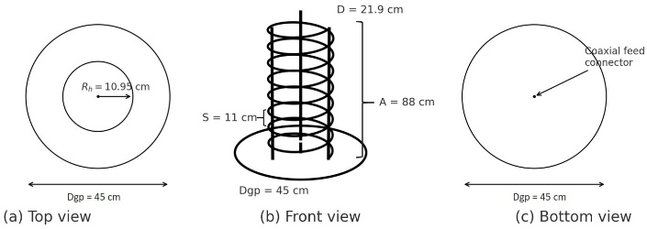

Figure 2. Antenna geometry after optimization. (a) Top view of the circular ground plane (Dgp = 45 cm) and helix position (radius Rh); (b) Front view showing the helical radiator with 8 turns, coil spacing S = 11 cm, and antenna total height A = 88 cm; (c) Bottom view of the ground plane and feed connector.
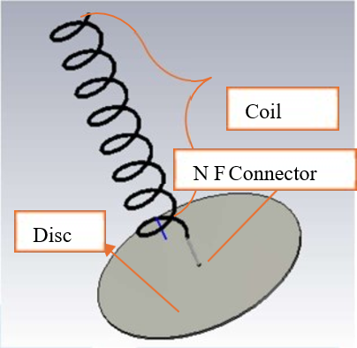

Figure 1. 3D display in the CST studio suite.
The fabrication process began with calculating the antenna dimensions based on an operating frequency of 435 MHz, resulting in key parameters such as wavelength, antenna diameter, distance between coils, antenna height, and ground plane diameter. The calculated values were then tested using CST Studio Suite simulation to ensure antenna performance in terms of VSWR, return loss, gain, and radiation pattern. Optimization is carried out to obtain ideal parameter criteria. After optimization, an antenna with eight coils, a distance between coils of 11 cm, and a ground plane with a diameter of 45 cm was determined to be the best design for fabrication, as seen in Figure 2. The detailed final fabricated dimensions are shown in Figure 10 for comparison purposes.
The design process was carried out by forming copper wire coils according to the simulation results, then installing them on the support pipe and attaching them to the aluminum ground plane. The female N connector was connected to the conductor coil using solder to ensure that the impedance met the standards. The fabrication results showed that the helix antenna could stand firmly even though it experienced imbalance due to the use of three pipe supports. This was then overcome by strengthening the adhesive between the pipe and the ground plane.
The results of the helix antenna design show that the fabrication process successfully produced an antenna in accordance with the simulation design. Overall, the fabricated helix antenna can be used in further testing, particularly to measure antenna performance at UHF frequencies.

Testing and Comparison
After the design and planning stages are complete, the next step is to conduct testing to obtain key data, namely VSWR values, forward power (P_{forward}), reverse power (P_{reverse}), gain, and radiation patterns. Testing is performed using a UHF Antenna Demonstrator as shown in Figure 3. Based on the test data, the return loss value is calculated using (9), while the bandwidth is determined using (10).
The UHF Antenna Demonstrator consists of three main components: a UHF transmitter that provides 13 frequencies in the range of 428.5-469.5 MHz, an SWR & power meter for reading VSWR and transmit power values, and an antenna control unit that displays the electric field intensity received by the receiving antenna.
Testing was conducted on two types of antennas, namely helix antennas and slot antennas, using identical procedures so that the results could be compared objectively. Figure 4a shows the configuration of the helix antenna test circuit, while Figure 4b shows the slot antenna test.
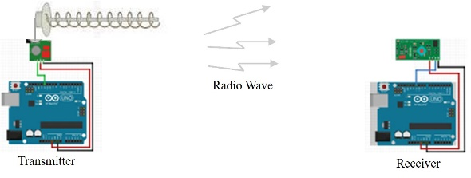
(a)

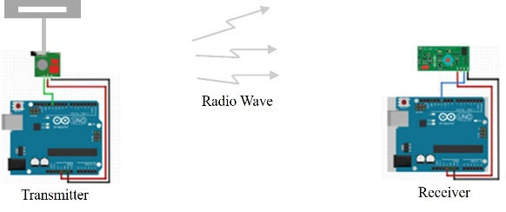
(b)

Figure 5. RF module circuit with antenna (a) Helix; (b) Slot.
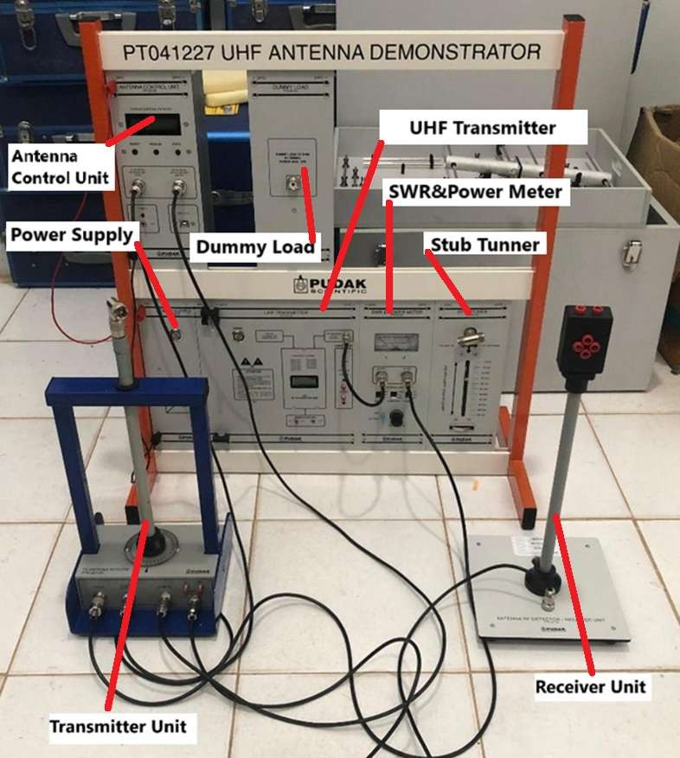

Figure 3. UHF antenna demonstrator.
In addition to conducting measurements using a demonstrator, this study also involved testing the transmission distance of a 433 MHz RF module controlled by Arduino Uno. The testing process was carried out in stages with 1-meter intervals under Line of Sight (LOS) conditions to ensure that the data obtained was free from physical obstacles. On the transmitter side, a helix antenna was installed according to the configuration shown in Figure 5a, while on the receiver side, a slot antenna was used as shown in Figure 5b. All measurements were carried out in a laboratory with a controlled environment so that external factors that could affect the results could be minimized. Under these conditions, the comparison results between the helix antenna and the slot antenna can be analyzed more accurately, while also providing a comprehensive overview of transmission performance at a frequency of 433 MHz.
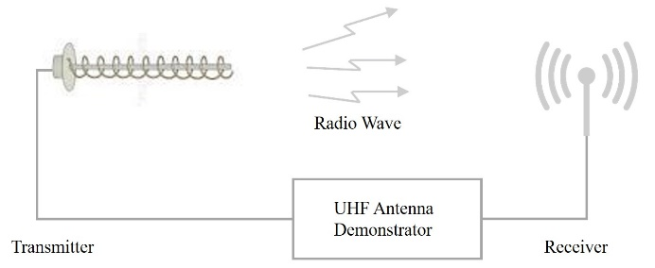
(a)
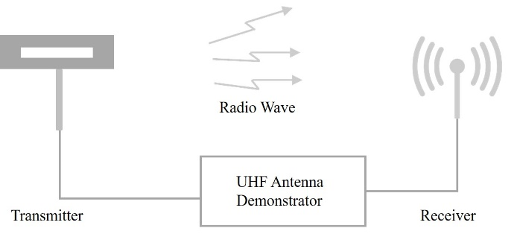
(b)

Figure 4. Antenna data acquisition circuit (a) Helix; (b) Slot.

RESULT AND DISCUSSION

Antenna Simulation and Optimization with CST Studio Suite
Antenna simulation was performed using CST Studio Suite to obtain a design that meets specifications for optimal performance. Key parameters such as VSWR, gain, radiation pattern, and return loss were analyzed to ensure antenna performance. The process began by entering theoretical dimensions, then varying the coil spacing, number of coils, and ground plane diameter to find the best conditions. The optimization results are targeted to produce low VSWR, return loss ≤ −10 dB, and high gain. This approach is similar to the research by [14], which systematically optimized antenna parameters to obtain the most optimal configuration.
Table 2 shows the simulation results with variations in ground plane diameter, while the number and distance of windings are kept constant. The ground plane plays an important role in antenna design because it functions as a reflector that can increase radiation efficiency [15]. The purpose of varying the ground plane diameter is to assess key antenna parameters such as gain, VSWR, and return loss, so that the configuration that provides the most optimal performance can be determined. The simulation results show that increasing the ground plane diameter from 40 cm to 55 cm causes an increase in the VSWR value, although not very significant, as also reported in [14]. The best gain value was achieved at a diameter of 55 cm, but under these conditions, the VSWR reached 2.7, which did not meet the standard. This indicates an impedance mismatch between the antenna and the system, so even though the gain increased, the overall performance of the antenna still needed to be further optimized.
TABLE 2
SIMULATION RESULTS BASED ON GROUND PLANE DIAMETER
Expe-riment | Number of coils | Coil Spacing (cm) | Diameter  GP (cm) | VSWR | Return loss  (dB) | Gain (dBi)
1 | 8 | 11 | 40 | 1.8 | -9.2 | 9.7
2 | 8 | 11 | 45 | 1.8 | -10.6 | 11.5
3 | 8 | 11 | 47 | 2.2 | -10.4 | 12.00
4 | 8 | 11 | 51.6* | 2.4 | -10.6 | 13.0
5 | 8 | 11 | 55 | 2.7 | -10.4 | 13.7
* Calculation result value

TABLE 3
SIMULATION RESULTS BASED ON THE NUMBER OF COILS
Expe-  riment | Number of coils | Coil Spacing (cm) | Diameter  GP (cm) | VSWR | Return loss  (dB) | Gain (dBi)
1 | 10 | 11 | 45 | 1.9 | -9.9 | 12.9
2 | 8* | 11 | 45 | 1.8 | -10.6 | 11.5
3 | 6 | 11 | 45 | 1.8 | -10.7 | 8.9
4 | 4 | 11 | 45 | 2.0 | -9.5 | 5.2
5 | 2 | 11 | 45 | 2.1 | -9.2 | 3.9
* Calculation result value
*Theoretical calculation result; other values are obtained from CST simulation.

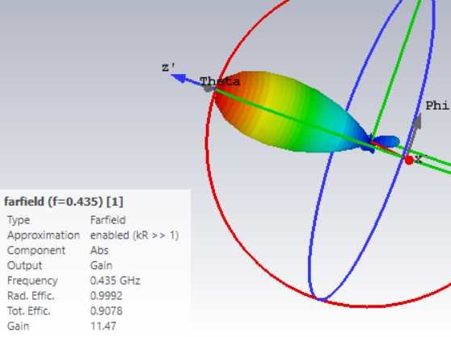

Figure 8. Helix antenna gain values.

Table 3 shows the simulation results of varying the number of turns used to analyze its effect on antenna efficiency. The number of turns was found to affect the gain value, so this variation was performed to evaluate the main parameters of the antenna, namely gain, VSWR, and return loss, in order to obtain the best performance. The simulation results show that 6 turns produce the lowest VSWR, but the gain value actually decreases.
Based on the overall simulation, including the number of turns, distance between turns, and ground plane diameter, one configuration with the best performance was selected for fabrication. The selected antenna has 8 turns, a distance between turns of 11 cm, and a ground plane diameter of 45 cm. These dimensions were selected according to the targeted specifications, with a VSWR value of 1.8, which indicates fairly good transmission efficiency. In addition, the gain value of 11.5 dBi shows that the antenna is capable of focusing or amplifying signals in a certain direction, making it suitable for the fabrication stage.
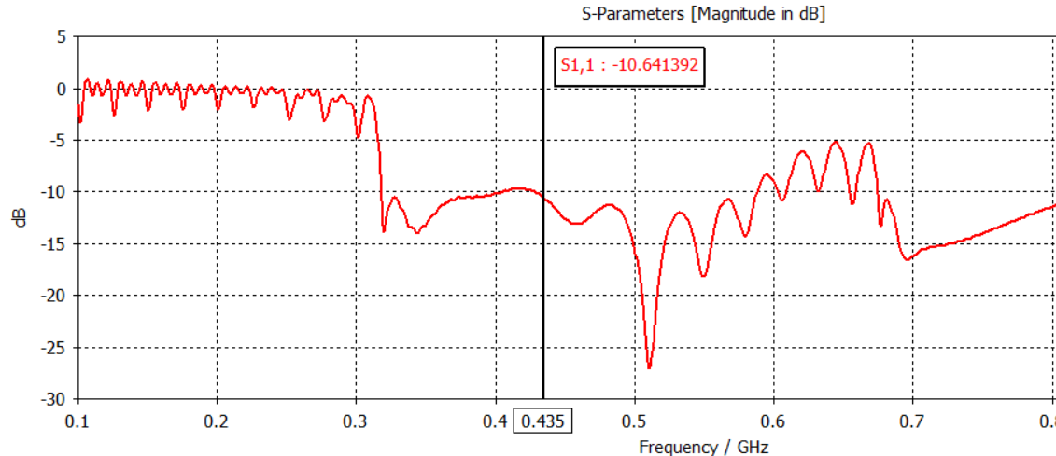

Figure 7. Return loss value of helix antenna.
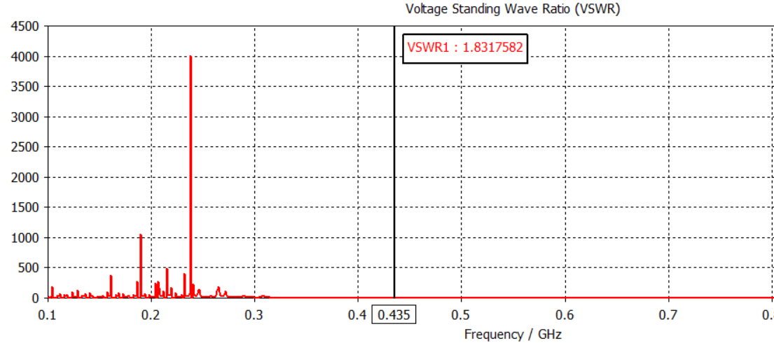

Figure 6. VSWR values of the helix antenna.
Figure 6 shows the VSWR results in graph form generated through simulation using the CST Studio suite. The VSWR values in the range of 1 to 2 indicate that the antenna is working well because not much power is reflected [16]. Figure 6 also shows that in the range of 0.1 GHz-0.3 GHz, there is a significant increase in the VSWR value. This occurs because the antenna is not designed for that frequency. The increase in VSWR also causes an increase in the reflection value [13]. A VSWR value of 1.8 can be categorized as an antenna suitable for fabrication.

Figure 7 shows the return loss graph in the simulation. At a frequency of 435 MHz, the return loss value produced is -10.6, which is categorized as good and meets the antenna fabrication requirements of ≤ -10 [14].
Figure 8 shows the gain results in 3D form obtained through simulation. The value of 11.47 dBi shown in the figure indicates that the antenna has high gain. If the antenna has a high gain value, it will be more effective in focusing the transmission in a certain direction [17]. The colors in the simulation results also illustrate the focused gain at the end of the helix antenna, which is red.
The far-field simulation of the helical antenna was conducted at an operating frequency of 0.435 GHz using the CST environment, with the configuration summarized in Table 4. The simulation adopts the kR >> 1 approximation to ensure accurate far-field computation, and the absolute gain was selected as the main output component. The antenna exhibits high radiation efficiency (99.92%) with a total efficiency of 90.78%, producing a peak gain of 11.47 dBi. These results confirm that the structure is capable of generating directional radiation suitable for IoT communication in the 433 MHz band.
Table 4
Simulation Parameters
Parameter | Value
Type | Farfield
Approximation | Enabled (kR >> 1)
Component | Abs
Output | Gain
Frequency | 0.435 GHz
Rad. Efficiency | 99.92%
Total Efficiency | 90.78%
Gain | 11.47 dBi

Figure 9 shows the radiation pattern obtained from the antenna simulation at a frequency of 435 MHz. Based on the graph, the radiation pattern illustrates that the antenna has directional characteristics, as can be seen in its main lobe, which is dominant at an angle of 0°. The angular width of 47.9° indicates that the helix antenna has a directional radiation pattern. The lobe describes the strongest signal emission, which can be seen in the figure as being emitted forward [17].
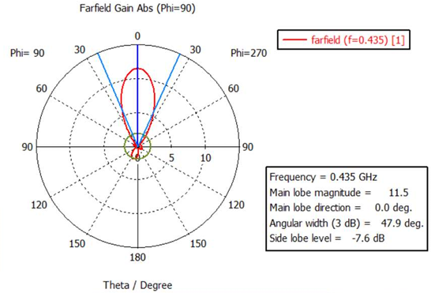

Figure 9. Radiation pattern of helix antenna simulation results.

Design Results
The physical design of the antenna was carried out based on simulations and optimizations performed using the CST Studio suite application. The design was carried out by adjusting the size based on the simulation results. The results of the physical design of the helix antenna can be seen in Figure 10.
The creation of three support pipes caused the antenna to be unbalanced during testing and resulted in a tilt in the antenna coil. However, this can be minimized by creating a strong connecting system or adhesive from the pipe to the ground plane. Overall, the design results are appropriate and function well.

Comparison of Single Frequency Antennas
The testing instrument and data collection tool, namely the UHF antenna demonstrator, displays the VSWR, Pf, and Pr values in analog form. Meanwhile, the return loss value is obtained by calculation using (9). The test results for the helix antenna and slot antenna can be seen in Table 5.
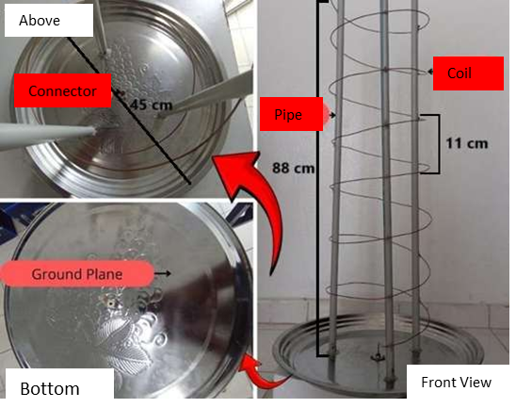

Figure 10. Results of helix antenna design.
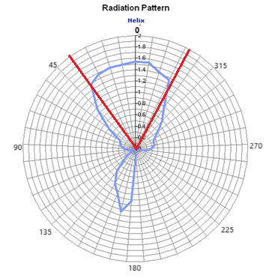
- (b)

Figure 11. Comparison of the helical antenna radiation patterns:
(a) Simulated far-field radiation pattern at 435 MHz; (b) Measured radiation pattern in open-field testing.
The results in the table show that the VSWR values of the helix antenna and slot antenna are within the acceptable range (≥1 and ≤2), with the helix antenna having the best value as it is close to 1. The reverse power is smaller than the forward power, in accordance with the antenna principle where most of the power is absorbed by the receiver [4]. The return loss value of the helix antenna is also lower than that of the slot antenna, which means less power reflection and better transmission.
TABLE 5
VSWR TEST RESULTS, HELIX ANTENNA POWER, AND SLOT ANTENNA POWER
Parameter | Helix Antenna | Slot Antenna
VSWR | 1.05 | 1.58
P_{forward} (Watt) | 200 | 200
P_{reverse} (Watt) | 0.1 | 10
Return Loss (dB) | -32.4 | -13.15

The radiation pattern of the helix antenna is directional with a beam angle of approximately 64°, which differs from the simulation result of 47.9°. Slot antennas are also directional, but they are wider with an angle of approximately 165° in the 90°–180° direction. The radiation pattern of a helix antenna is more focused on 0°, although there is a back lobe due to the ground plane effect that can be seen in Figure 11 and 12. Both results show a directional main lobe with similar beam orientation. Small variations in the measured pattern are caused by measurement noise, environmental reflections, and fabrication conditions. The similarity trend confirms that the antenna radiates directionally as predicted by simulation.
The radiation pattern produced by the helix antenna shows the identity of the helix antenna as an antenna with a directional radiation pattern. Meanwhile, the radiation pattern of the slot antenna obtained from this test is classified as directional, but has a relatively wider characteristic compared to the helix antenna. The antenna produces a radiation pattern that is focused straight (pointing to 0°), although there is a minor lobe in the form of a back lobe caused by the influence of the edge effect on the ground plane. The slot antenna shows a pattern that forms a full circle, so it cannot be categorized as omnidirectional.

Comparison of Multi-Frequency Antennas
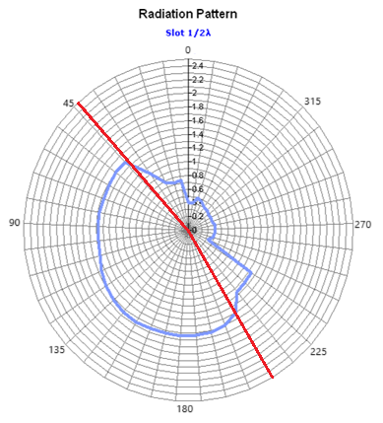
Figure 12. Slot antenna radiation pattern.
In the multi-frequency comparison, data was obtained through testing at 13 different frequencies, between 428.5 MHz and 469.5 MHz. The results obtained can be seen in Table 6.

Discussion

VSWR
Figure 13 and Table 5 show a comparison of the VSWR of helical and slot antennas at frequencies of 428.5–469.5 MHz. The helical antenna has a lower VSWR, indicating better impedance matching and power transmission efficiency. At frequencies of 428.5 MHz and 430 MHz, the helix antenna achieves an optimal value of 1.00, while the slot antenna only reaches 1.11.
At higher frequencies, both antennas experience an increase in VSWR, with a greater increase in the slot antenna. At 463 MHz, the slot recorded a value of 2.05, exceeding the optimal limit (≥1 and ≤2). This condition indicates impedance mismatch due to antenna design limitations, narrow bandwidth, and the influence of antenna materials or dimensions.
TABLE 6
MULTI-FREQUENCY TEST RESULTS FOR HELIX ANTENNAS AND SLOT ANTENNAS
No | Frequency  (MHz) | Helix Antenna |  |  |  | Slot Antenna
No | Frequency  (MHz) | Pf  (Watt) | Pr  (Watt) | VSWR | Return  Loss  (dB) | Pf  (Watt) | Pr  (Watt) | VSWR | Return  Loss  (dB)
1 | 428.5 | 210 | 0 | 1 | -20.00 | 200 | 0.5 | 1.11 | -26.02
2 | 430 | 210 | 0 | 1 | -20.00 | 200 | 0.5 | 1.11 | -26.02
3 | 435 | 200 | 0.1 | 1.05 | -33.01 | 200 | 10 | 1.58 | -13.01
4 | 443 | 220 | 15 | 1.71 | -11.66 | 220 | 15 | 1.71 | -11.66
5 | 447.5 | 220 | 17 | 1.77 | -11.12 | 220 | 10 | 1.54 | -13.42
6 | 450 | 220 | 20 | 1.86 | -10.41 | 220 | 10 | 1.54 | -13.42
7 | 452.5 | 220 | 22 | 1.92 | -10.00 | 220 | 15 | 1.71 | -11.66
8 | 457.5 | 220 | 17 | 1.77 | -11.12 | 210 | 17 | 1.8 | -10.92
9 | 460.5 | 210 | 15 | 1.73 | -11.46 | 210 | 20 | 1.89 | -10.21
10 | 463 | 210 | 10 | 1.56 | -13.22 | 210 | 25 | 2.05 | -9.24
11 | 465.5 | 220 | 15 | 1.71 | -11.66 | 220 | 40 | 2.49 | -7.40
12 | 468.5 | 220 | 17 | 1.77 | -11.12 | 200 | 30 | 2.26 | -8.24
13 | 469.5 | 210 | 20 | 1.89 | -10.21 | 190 | 25 | 2.14 | -8.81

Return loss
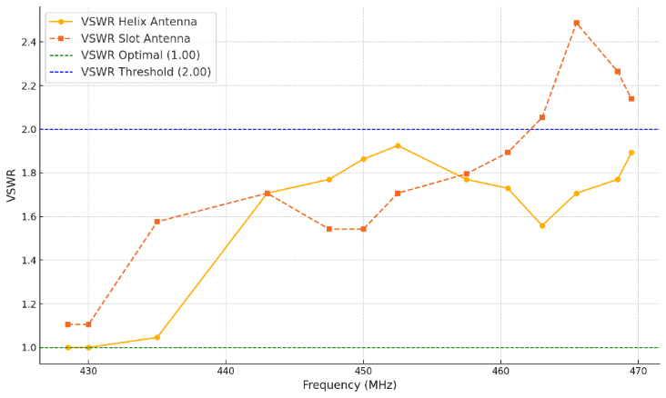

Figure 13. VSWR comparison graph.
Based on Figure 14, the helix antenna shows more stable and generally better return loss performance than the slot antenna in the 428.5-469.5 MHz range. At frequencies of 428.5 MHz and 430 MHz, both antennas have excellent impedance matching, with values of −20 dB for the helix and −26 dB for the slot [16].
However, at a frequency of 435 MHz, the helix achieved a return loss of −33.01 dB, which was much better than the slot antenna, which only achieved −13.01 dB, indicating that the impedance matching of the helix was more optimal. At frequencies above 450 MHz, both antennas experienced a decrease in return loss. The helix still remained in the range of −10 to −13 dB, which is considered good, while the slot decreased more significantly, especially at 463–469.5 MHz with values above −10 dB, indicating less than ideal impedance matching [16].
Return Loss measurement uses the P_{forward} and P_{reverse} parameters, where P_{forward} indicates the transmitted power and P_{reverse} indicates the reflected power due to impedance mismatch [4]. The ratio of the two is an important indicator of antenna efficiency.

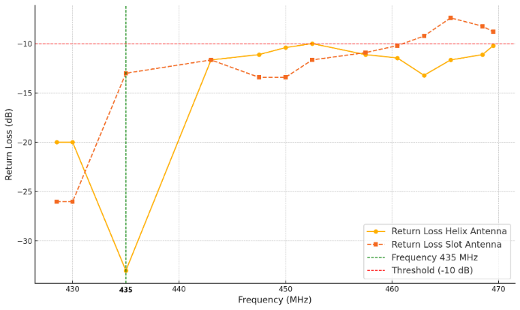

Figure 14. Return loss comparison chart.
Figure 15 shows that the helix antenna is more stable than the slot antenna. At low frequencies, the helix transmits more power (210 Watts vs. 200 Watts), while at 443–450 MHz, both are equivalent at around 220 Watts. However, at high frequencies, the slot drops dramatically to 190 Watts, while the helix remains stable at around 210 Watts. This confirms that the helix is more efficient at high frequencies.
Figure 16 illustrates a significant difference in impedance mismatch performance between the helix and slot antennas over the frequency range of 428.5–469.5 MHz. At lower frequencies (428.5–435 MHz), the helix antenna exhibits very low reflected power (approximately 0–0.1 W), whereas the slot antenna shows much higher values, reaching up to 10 W at 435 MHz, indicating better impedance matching for the helix antenna. As the frequency increases to the mid and high range (443–468.5 MHz), the reflected power of the helix antenna rises to approximately 20 W but remains substantially lower than that of the slot antenna, which increases sharply to around 40 W at 465.5 MHz. These results demonstrate that the helix antenna maintains superior impedance matching and higher power transmission efficiency across the investigated frequency range.
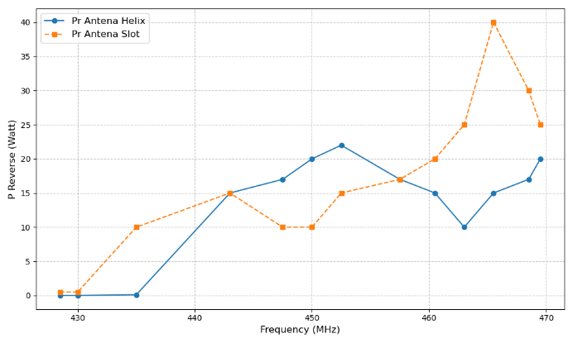

Figure 16. P_{Reverse} comparison graph.

Bandwidth
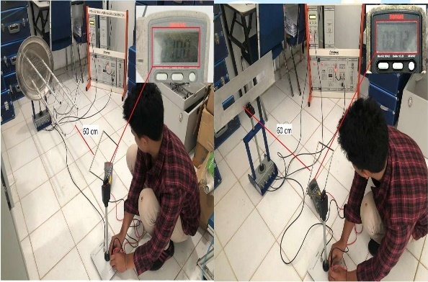
(a) (b)

Figure 17. Measurement of gain value in the form of received voltage from (a) Helix antenna; (b) Slot antenna.

The test results in Table 5 show that the helix antenna is capable of operating at 13 frequencies with a bandwidth of approximately 41 MHz (428.5–469.5 MHz), while the slot antenna only operates at 9 frequencies with a bandwidth of 32 MHz (428.5–460.5 MHz). The VSWR values of both are still within operational limits (1–2), but the helix is expected to remain functional slightly above 469.5 MHz and below 428.5 MHz, while the slot is only effective at frequencies below 428.5 MHz. Thus, the helix antenna has a wider bandwidth and is superior for applications requiring a wide frequency range [18].
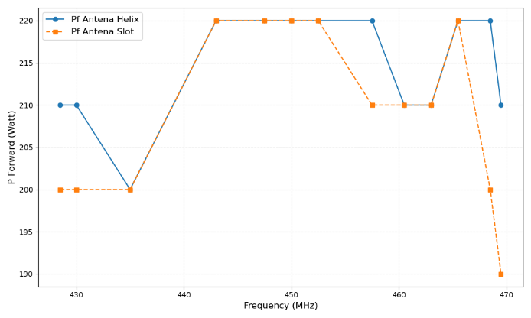
Figure 15. P_{Forward} comparison graph.

Gain
Gain measurement cannot be performed directly with the UHF antenna demonstrator, so a voltage measurement method was used on the receiver unit at a distance of 60 cm, as shown in Figure 17a for the helix antenna and Figure 17b for the slot antenna. The test results show that the helix antenna produces a received voltage of 10 mV, which is much higher than the slot antenna, which only produces 1.2 mV. This difference confirms that the helical antenna has greater gain, enabling it to focus energy more effectively in a specific direction and receive signals with higher intensity than the slot antenna.

Radiation Pattern
The radiation pattern describes the distribution of antenna power at a given angle. Based on the measured radiation patterns presented in Figure 18, the helical antenna shows a more directional main lobe with higher maximum gain, while the slot antenna exhibits a more omnidirectional pattern with lower overall gain. This behavior is consistent with typical characteristics where the helix geometry tends to enhance effective electrical length and radiation concentration, whereas slot antennas distribute radiation more evenly but at reduced gain performance. These results support the suitability of the proposed helix antenna for IoT communication links that require directional transmission and improved link budget. This difference shows that the helix is more suitable for communication requiring power directed at a narrow angle, while the slot is more suitable for wide coverage but still directional [19].
Antenna
IoT module
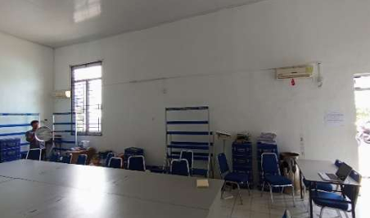
(a)
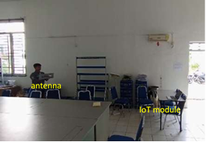
(b)

Figure 20. Measurement with IoT module (a) using Helix antenna (b) using Slot antenna.

Figure 18. Radar graph comparing electric field strength.

Transmission Distance
Transmission distance testing was conducted using a 433 MHz RF module designed as shown in Figure 19, with the test location in an open area. This frequency was chosen because it was suitable for testing helical and slot antennas. The RF module was controlled by Arduino Uno as a microcontroller and indicator medium through the serial monitor feature. The receiver module was connected to a laptop to monitor the data, while the transmitter module was connected to the helix and slot antennas and powered by a power bank that can be seen in Figure 20. Measurements were taken every 1 meter under three conditions: without an antenna, using a helix antenna, and using a slot antenna.
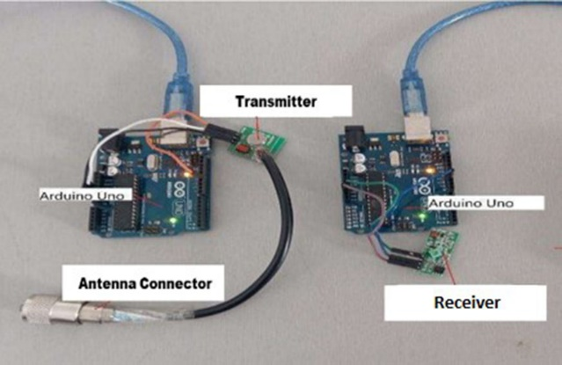

Figure 19. 433 MHz RF module circuit.
Based on the data in Table 4, the use of helix and slot antennas has been proven to significantly increase transmission distance compared to no antenna. The helix antenna showed the best performance with a maximum distance of 25 meters, confirming its ability to strengthen signals, making it suitable for long-distance communication applications.
Meanwhile, slot antennas can reach a distance of 15 meters, remaining effective even though they are not as optimal as helix antennas. In comparison, transmission without antennas only reaches 6 meters, which confirms the importance of using antennas in improving signal efficiency and range that can be seen in Table 7.
The performance improvement is attributed to the longer electrical path of the helix structure, which increases the effective radiation aperture and produces higher gain, as validated in Table 6 and Figure 18. Meanwhile, the slot antenna offers moderate improvement but still remains below the performance of the helical antenna, as the comparison can be seen in Figure 21.
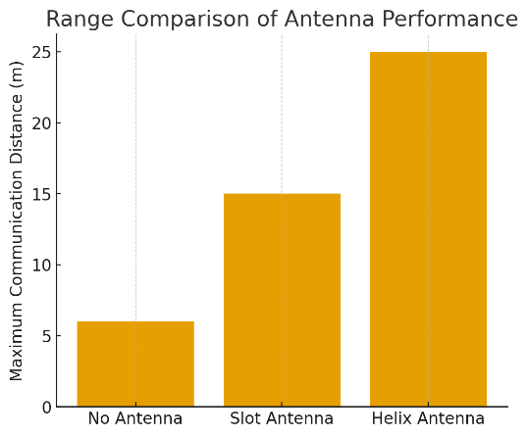
Figure 21. Range comparison of antenna performance.

CONCLUSION
Based on the research results, it can be concluded that the designed helix antenna successfully meets standard specifications and demonstrates optimal performance at a frequency of 435 MHz with a Voltage Standing Wave Ratio (VSWR) value of 1.05, return loss of -32.4 dB, bandwidth of 41 MHz, and a directional radiation pattern with an appropriate angle of 64°. The slot antenna, although also meeting the standards, has a VSWR value of 1.58, a return loss of -13.15 dB, a bandwidth of 32 MHz, and a wider directional radiation pattern than the helix antenna, namely 165°. Gain performance is indicated by the voltage at the receiver unit, where the helix antenna transmits a voltage of 10 mV, while the slot antenna transmits a voltage of 1.2 mV. In transmission distance testing, without an antenna, the signal only reached 6 m, but with a helix antenna the distance increased to 25 m and with a slot antenna to 15 m. These results indicate that the helical antenna has superior performance in transmission efficiency and radiation focus compared to the slot antenna at the tested frequency.

Declarations

Conflict of Interest
The authors have declared that no competing interests exist.

CRediT Authorship Contribution
TABLE 7
ANTENNA TRANSMISSION MEASUREMENT RESULTS
Distance (m) | Without Antenna | Helix  Antenna | Slot Antenna
1 | Received | Received | Received
2 | Received | Received | Received
3 | Received | Received | Received
4 | Received | Received | Received
5 | Received | Received | Received
6 | Received | Received | Received
7 | Not Received | Received | Received
8 | Not Received | Received | Received
9 | Not Received | Received | Received
10 | Not Received | Received | Received
11 | Not Received | Received | Received
12 | Not Received | Received | Received
13 | Not Received | Received | Received
14 | Not Received | Received | Received
15 | Not Received | Received | Received
16 | Not Received | Received | Not Received
17 | Not Received | Received | Not Received
18 | Not Received | Received | Not Received
19 | Not Received | Received | Not Received
20 | Not Received | Received | Not Received
21 | Not Received | Received | Not Received
22 | Not Received | Received | Not Received
23 | Not Received | Received | Not Received
24 | Not Received | Received | Not Received
25 | Not Received | Received | Not Received

Rusfa: Conseptualization, Methodology, Writing – Review & Editing; Rozeff Pramana: Data Curation, Investigation, Writing – Review & Editing; Bavitra: Validation, Visualization; Ferly Oktavia: Investigating and Editing; M. Hasbi Sidqi Alajuri: Formal Analysis, Investigation; Andreas M Simannulang: Software, Data Aquitition, and Writing Original Draft.

Funding
This work was supported by the Research and Community Service Institute of Raja Ali Haji Maritime University (LPPM – UMRAH, Directorate of Research and Community Service, Directorate General of Research and Development, Ministry of Higher Education, Science, and Technology, the Republic of Indonesia, under contract number 046/UN53.0004/Kontrak – PDP/2025.

Acknowledgment
The authors would like to express their sincere gratitude to the Directorate of Research and Community Service, Directorate General of Research and Development, Ministry of Higher Education, Science, and Technology, as well as the Institute for Research and Community Service (LPPM) of Universitas Maritim Raja Ali Haji (UMRAH), for their valuable support and funding that made this research possible.
We also extend our heartfelt thanks to all team members who were involved in this research, especially to Andreas M Simannulang, Masta Angel V. Pardede, and Shyndi Febrina Hutabalian for their generosity and kind support in helping make this research a reality.

References
[1] E. Heptaniarti, I. Gusti Putu Asto Buditjahjanto, and M. Rohman, “Design and development of a patch antenna for rectenna in electromagnetic wave energy harvesting technology,” (in Indonesian), J. Tek. Elektro, vol. Vol 13, no. 1, pp. 88–93, 2024, [Online]. Available: https://ejournal.unesa.ac.id/index.php/JTE/article/view/58721.
[2] N. I. Luthfiah, “Optimization of library services using RFID technology at the UPT ITB library,” (in Indonesian), J. Multidisipliner Kapalamada Kapalama, vol. 2, no. 4, pp. 240–252, 2023, doi: https://doi.org/10.62668/kapalamada.v2i04.837.
[3] S. Munziah, I. Muhammadi, and M. P. K. Praja, “Analysis of radiation pattern and gain of a C-band Cassegrain antenna,” (in Indonesian), J. Telecommun. Electron. Control Eng., vol. 6, no. 2, pp. 152–162, Jul. 2024, doi: 10.20895/JTECE.V6I2.1212.
[4] S. Hartanto, “Design and development of ½λ slot antenna at 407 MHz,” (in Indonesian), J. Elektro, vol. 8, no. 1, pp. 18–27, Jan. 2020, Accessed: Dec. 04, 2025. [Online]. Available: https://jurnalteknik.unkris.ac.id/index.php/jie/article/view/199
[5] M. Badriansyah et al., “Design and development of a helix antenna as an internet network booster for a MiFi modem in Sungai Ambangah Village,” (in Indonesian), J. Electr. Eng. Energy, Inf. Technol., vol. 9, no. 1, Jan. 2021, doi: 10.26418/J3EIT.V9I1.44512.
[6] C. Suarez Fajardo et al., “Suspended plate antenna with circular polarization and configurable sense of rotation,” INGE CUC, vol. 16, no. 1, pp. 156–170, 2020, doi: 10.17981/ingecuc.16.1.2020.011.
[7] K. Bangkalan, Y. N. Pratama, M. Ulum, and D. Rahmawati, “Design and development of a helix antenna as a GSM signal booster to support communication (case study at Darul Hadist School, Klapayan Village, Bangkalan Regency,” (in Indonesian), SinarFe7, vol. 2, no. 1, pp. 141–148, Aug. 2019, Accessed: Dec. 04, 2025. [Online]. Available: https://journal.fortei7.org/index.php/sinarFe7/article/view/414
[8] N. Destria et al., “Design of 2.4 GHz Helix antenna for increasing wifi signal strength using Mmanagal and wirelesmon application,” Int. Conf. Comput. Eng. Des., vol. 2018-March, pp. 1–5, Jul. 2017, doi: 10.1109/CED.2017.8308117.
[9] Z. R. M. Hajiyat, A. Ismail, A. Sali, and M. N. Hamidon, “Design and analysis of helical antenna for short-range ultra-high-speed THz wireless applications,” Optik (Stuttg)., vol. 243, p. 167232,
Oct. 2021, doi: 10.1016/J.IJLEO.2021.167232.
[10] Rizky Andromedha Persia, “Study of a microstrip array antenna at 850 MHz,” (in Indonesia), J. Penelit. Rumpun Ilmu Tek., vol. 1, no. 2, pp. 06–11, May 2022, doi: 10.55606/JUPRIT.V1I2.467.
[11] D. M. Handika, “Design and development of a circular patch microstrip antenna for 5G applications,” (in Indonesian), Data Sci. Indones., vol. 2, no. 1, pp. 9–12, Jun. 2022, doi: 10.47709/DSI.V2I1.1518.
[12] S. L. Miller and D. Childers, Probability and Random Processes: With Applications to Signal Processing and Communications, Second Edi. Elsevier Inc., 2012. doi: 10.1016/C2010-0-67611-5.
[13] H. Darmono and M. A. Anshori, “Design and implementation of an 8-element microstrip array antenna at 2.4 GHz to support wireless local area networks,” (in Indonesian), J. Tek. Ilmu dan Apl., vol. 4(1), pp. 8–14, 2023, Accessed: Dec. 04, 2025. [Online]. Available: https://jurnal.polinema.ac.id/index.php/jtia/article/view/2790
[14] M. R. Hidayat, Aditya Febryana, N. T. Somantri, and Y. P. Saputera, “Axial-mode helix antenna for S-band radar operating frequency,” (in Indonesian), J. Tek. Media Pengemb. Ilmu dan Apl. Tek., vol. 22, no. 1, pp. 23–35, Sep. 2023, doi: 10.55893/JT.VOL22NO1.478.
[15] M. M. Lumembang, A. Bualkar, A. Arifin, J. Perintis, K. Km10, and S. Selatan, “Characterization of Slot Bowtie Microstrip Antenna at 2.4 GHz Frequency,” (in Indonesian), Risal. Fis., vol. 3, no. 1, pp. 1–4, 2019.
[16] H. Muchtar and T. Firmansyah, “Design and simulation of a helix antenna at 2.4 GHz,” (in Indonesian), J. Elektum, vol. 15, no. 2, pp. 27–32, 2015, Accessed: Dec. 04, 2025. [Online]. Available: https://jurnal.umj.ac.id/index.php/elektum/article/view/3188
[17] R. Rianza et al., “Conventional Vivaldi antenna for weather radar applications at 9.4 GHz,” (in Indonesian), Elektron J. Ilm., pp. 1–6, Jun. 2022, doi: 10.30630/eji.14.1.236.
[18] F. Marintis, Y. Christiyono, and I. Santoso, “Design of a helix antenna to improve received power of low-level GSM 900 signals,” (in Indonesian), Transient J. Ilm. Tek. Elektro, vol. 3, no. 4, pp. 536–545, Feb. 2015, doi: 10.14710/TRANSIENT.V3I4.536-545.

