PID Controller-Based Closed-Loop Fast Charging of Lithium-Ion Batteries Using the CCCV Method

Tole Sutikno^{a,b,*}, Tri Wahono^{a,b}, Ahmad Raditya Cahya Baswaraª
ªFaculty of Industrial Technology
Ahmad Dahlan University
Campus 4, Jl. Ring Road Selatan, Kragilan, Tamanan, Banguntapan, Bantul
Yogyakarta 55191, Indonesia
^{b}Embedded System and Power Electronics Research Group
JEC Residence, No. B2, Plumbon, RT 12, Jl. Sukun Raya, Modalan, Banguntapan, Bantul
Yogyakarta 55198, Indonesia

Abstract
This paper presents a closed-loop fast charging system for lithium-ion batteries based on the Constant-Current Constant-Voltage (CCCV) method enhanced with a Proportional Integral Derivative (PID) controller. The proposed system dynamically regulates the charging parameters by using real-time feedback from voltage and current sensors, with the aim of improving the efficiency of the charging and ensuring battery safety. Experimental results demonstrate that the PID-controlled method maintains a higher current during the initial bulk charging phase, significantly reduces total charging time, and avoids harmful voltage overshoot. Compared to conventional CCCV charging, the system achieves more stable voltage regulation and gradual current tapering, effectively minimizing thermal stress and preventing overcharging. A comparative analysis shows that the PID approach outperforms traditional methods in terms of energy efficiency, thermal management, and operational safety. The system architecture is suitable for integration into Battery Management Systems (BMS) of electric vehicles, portable electronics, and renewable energy storage. This research not only validates the practicality of using PID in fast charging applications but also lays the foundation for future enhancements using intelligent control strategies and adaptive learning algorithms. The findings suggest that PID-controlled charging systems offer a promising solution to the challenges of rapid, reliable, and safe energy replenishment in modern battery-powered technologies.

Keywords: fast charging, lithium-ion battery, PID controller, CCCV method, closed-loop control, battery management system.

Introduction
Lithium-ion batteries (LIBs) are widely used in various applications, including electric vehicles (EVs), portable electronics, and renewable energy storage, due to their high energy density and long cycle life [1]–[4]. However, conventional charging methods can be inefficient and can lead to battery degradation, overheating, and safety concerns. Fast charging techniques are essential to meet the growing energy demands and reduce charging times without compromising battery lifespan.
Traditional charging methods, while effective, often suffer from inefficiencies that can lead to battery degradation, increased internal resistance, overheating, and safety risks. These issues are particularly critical in EV applications, where reducing charging time without compromising battery health is essential for widespread adoption. Fast charging techniques, such as the CCCV method, provide a structured approach to optimize the charging process [5]–[8]. However, the implementation of additional control mechanisms, such as PID controllers, is necessary to enhance efficiency, regulate thermal conditions, and prevent adverse effects such as overcharging and thermal runaway
* Corresponding Author.
Email: tole@te.uad.ac.id
Received: June 10, 2025 ; Revised: July 7, 2025
Accepted: Agustus 11, 2025 ; Published: December 31, 2025

Open access under CC-BY-NC-SA
© 2025 BRIN
25-32

The primary challenge in fast charging LIBs is balancing speed and safety while minimizing adverse effects such as overcharging, thermal runaway, and capacity degradation. The conventional CCCV charging method provides a structured approach, but additional control mechanisms are required to optimize performance and ensure stability [5], [9], [10]. The conventional CCCV charging method provides a structured approach by initially applying a constant current until a predefined voltage is reached, followed by a constant voltage phase where the current gradually decreases [11]. However, without proper feedback control, this method may not optimize efficiency and battery longevity. Additional control mechanisms, such as a PID controller, are required to dynamically adjust charging parameters based on real-time battery conditions, ensuring stability and optimal performance.
Several recent studies have focused on improving lithium-ion battery charging using control-based strategies. PID controllers, in particular, have shown potential in achieving fast and safe charging through feedback mechanisms. For instance, Kaleem et al. [8] developed a closed-loop PID-controlled fast charger and demonstrated improvements in current regulation. Wang et al. [12] implemented an optimization-enhanced PID approach using particle swarm optimization (PSO) for lithium-ion batteries, achieving better response and efficiency. In addition, relevant research from the Journal of Electronics and Telecommunications supports the integration of PID and embedded control systems in battery applications. For example, Rospawan and Simatupang [13] developed a microcontroller-based battery balancing system for electric vehicles, while Irawan et al. [14] implemented a smart power bank with battery monitoring and protection. These studies highlight the importance of intelligent control and real-time feedback, which underpin the proposed PID-based fast charging method in this work.
This paper aims to develop a PID controller-based closed-loop fast charging system using the CCCV method to: improve charging efficiency while maintaining battery safety; Regulate temperature and voltage fluctuations during the charging process; Minimize capacity loss and extend battery lifespan. The key contributions of this research include: Design and implementation of a closed-loop PID controller for CCCV-based charging; Analysis of current and voltage regulation under different charging conditions; Experimental validation of the proposed system against conventional charging methods.

LITERATURE REVIEW

Lithium-Ion Battery Charging Methods
Several charging techniques have been explored for lithium-ion batteries (Lithium-Ion Batteries or LIBs), along with the increasing need for battery efficiency, safety, and longevity. These techniques are designed to optimize the charging process to match the chemical and physical characteristics of lithium-ion batteries, as well as to avoid conditions that could lead to battery degradation or even failure [1], [15]–[17]. One of the most commonly used methods is the Constant Current (CC) technique [2]. In this method, the battery is charged using a predetermined fixed current. Charging takes place at a constant rate until the battery voltage reaches a certain threshold, usually close to the maximum voltage allowed for that type of battery. This technique is relatively simple and efficient in the early stages of charging, as it allows for rapid transfer of energy into the battery. Once the maximum voltage is reached, the charging process is usually continued with the Constant Voltage (CV) method. At this stage, the voltage is kept constant while the charging current gradually decreases. The drop in current occurs naturally because the potential difference between the power source and the battery gets smaller over time. The CV stage aims to slowly and safely charge the remaining battery capacity while reducing the risk of overcharging that can damage the internal structure of the battery. The combination of CC and CV techniques is often used in modern filling systems to ensure a fast, yet safe, and efficient filling process. This approach not only extends the battery life but also helps maintain optimal performance throughout its lifecycle. Figure 1 illustrates the standard CCCV charging profile commonly used for lithium-ion batteries. The charging process begins with a C) phase, where the battery is charged with a fixed current until it reaches the maximum voltage threshold. Once this voltage is achieved, the charger transitions to the CV phase, where the voltage is held steady, and the current gradually decreases. This two-stage process helps ensure fast initial charging while protecting the battery from overvoltage damage in the later stage. The figure visually represents this transition and the typical behavior of current and voltage over time. Research is constantly being conducted to refine these techniques and develop new methods that are more adaptive to the specific conditions and needs of battery users [10].
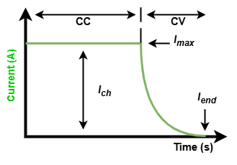
Figure 1. Standard CCCV Method

Control Strategy in Battery Charging
In battery charging systems, there are two main approaches to process control, namely open-loop and closed-loop methods. The open-loop method is a traditional approach that works without considering the feedback of the system [18]–[20]. This means that the charging process is carried out based on predetermined parameters without any adjustment to the actual condition of the battery during charging. Although simple, this method has limitations in terms of flexibility and response to changing conditions, such as battery temperature, cell life, or system load. In contrast, the closed-loop method offers a more adaptive and responsive solution. The closed-loop system uses feedback from important parameters such as voltage, current, and battery temperature to make real-time adjustments. This approach allows the charging system to respond to the dynamics of the battery more accurately, thus improving the efficiency and safety of the charging process. One of the most commonly used forms of closed-loop control is PID control [8].
The use of PID control in battery management systems (BMS) is very broad due to its simplicity of implementation and its ability to provide stable and accurate responses. The PID controller works by calculating the difference between the actual value and the desired value (setpoint), and then adjusting the control signal to minimize the difference. The proportional component is in charge of responding to current errors, the integral component takes into account the accumulation of past errors, while the derivative component predicts future errors. The combination of these three components allows the system to keep battery charging conditions within safe and optimal limits [21]. With the application of PID control, the battery charging system can precisely regulate the charging current and voltage according to the actual condition of the battery. This not only improves energy efficiency, but also helps extend battery life and reduces the risk of damage due to overcharging or uncontrolled temperatures. Therefore, the closed-loop approach with PID control is becoming an increasingly adopted standard in modern battery charging technology, both for portable devices and electric vehicles.
Several studies have explored the application of PID control for battery charging to improve system responsiveness and stability. For example, Kaleem et al. [8] proposed a closed-loop fast charging system based on feedback PID and demonstrated improved regulation of charging current and voltage in real time. Wang et al. [12] employed an enhanced PID algorithm optimized via particle swarm optimization (PSO) to further improve accuracy and response time. Similarly, Rad et al. [22] developed a nonlinear PID control strategy for battery charger evaluation using a CHIL (Controller Hardware-in-the-Loop) setup, showing significant improvements in stability and overshoot suppression. These works support the feasibility and effectiveness of PID implementation in dynamic charging environments, which is the basis for the approach presented in this document.

Challenges in Fast Charging
Fast charging has become an important feature in a variety of applications, especially in portable electronic devices and electric vehicles. However, in addition to its advantages in saving time, fast charging also presents a number of technical challenges that are quite complex. These challenges relate to the safety, efficiency and long-term durability aspects of the battery itself [1][23].
One of the main problems with fast charging is overheating or an excessive increase in temperature. When high charging currents are used to speed up the process, the internal resistance of the battery causes a significant increase in temperature. If not properly controlled, overheating can trigger harmful chemical reactions, accelerate the degradation of battery cells, and even pose a risk of fire or explosion. Therefore, thermal management is a critical aspect in the design of a fast-charging system. Active or passive cooling systems are often applied to keep the temperature within safe limits [4], [21], [24].
In addition to heat, overcurrent and overcharging are also serious challenges. Too high a current not only accelerates heating, but can also damage the internal structure of the battery, accelerate electrolyte wear, and reduce overall efficiency [25], [26]. Meanwhile, uncontrolled charging beyond the maximum voltage limit can lead to permanent degradation of capacity. Overcharging also has the potential to create chemical instability in the battery, leading to cell bulging or even leakage.
To address this risk, a reliable overcharging prevention system is required, such as real-time voltage and current monitoring, as well as the implementation of smart controls that can stop charging when the parameters have reached safe limits. Efficiency optimization is also an important focus, where the challenge lies in how to balance charging speed with minimal energy loss. Inefficient fast charging not only wastes energy but also accelerates battery aging. In general, while fast charging offers convenience and time efficiency, its implementation must take into account a variety of technical challenges that can affect battery safety and life [27], [28].

SYSTEM DESIGN AND METHODOLOGY

Overview of the Charging System
The architecture of the PID-based fast charging system and the CCCV method are designed to provide efficient, safe, and adaptive charging to battery conditions. The system combines several essential components that work in an integrated closed-loop control framework, allowing dynamic adjustments during the charging process.
One of the key components of this architecture is the power supply that provides electrical energy with the appropriate capacity and voltage for fast charging. This energy is then fed to a CCCV charger controlled by the PID algorithm, which is in charge of regulating the charging process with two main stages. In the first stage, the battery is charged with constant current until it reaches a certain voltage limit. After that, the charge continues with constant voltage while the current gradually decreases until it reaches the minimum threshold.
The PID controller sets the charging parameters in real-time. These controllers receive input from various sensors, such as voltage and current sensors, which monitor the condition of the battery during the charging process, and which monitor the condition of the battery during the charging process. Based on these data, the PID controller adjusts the control signal to maintain current and voltage stability according to the predetermined setpoint [12], [22]. This allows the system to respond quickly and precisely to changes in battery conditions, avoiding the risk of overcharging, overheating, or damage due to voltage instability.
The entire process is controlled and coordinated by a microcontroller, which serves as the brain of the charging system. The microcontroller runs a closed control algorithm, processes sensor data, and adjusts the output of the charger to meet optimal charging needs. With this approach, the charging system architecture not only ensures energy efficiency, but also extends battery life and increases operational safety levels, especially in the context of fast charging that demands high performance.

PID Control Strategy
The PID controller is a type of control system that is widely used to regulate various variables in an engineering system, including voltage and temperature. In its setup, the PID controller works by combining three main components, namely proportional (P), integral (I) and derivative (D). The integral component (I) has an important function in reducing steady-state errors over time, by accumulating errors and adjusting the output to slowly but surely correct deviations. Meanwhile, the derivative component (D) plays a role in predicting future errors by analyzing the rate of error change, so that it can help prevent overshoots or excessive spikes in the system. By combining these three components, the PID controller is able to provide stable and responsive control to changing conditions, making it very effective in maintaining voltage and temperature stability in the system it controls. It shows in Figure 2.
Figure 2 illustrates the implementation of PID control in both current and voltage regulation. In part (a), the PID controller regulates the charging current during the constant current (CC) phase by comparing the measured current with the reference set point and adjusting the duty cycle accordingly. In part (b), during the constant voltage (CV) phase, the controller maintains the output voltage at the predefined level by modifying the control signal based on the voltage error. Both sub-figures highlight the real-time feedback loop that ensures the system operates within safe and efficient charging parameters.
The PID controller used in this study was implemented using the PID_v2 library in embedded C. The tuning parameters were selected on the basis of iterative trial-and-error testing to achieve a balance between fast response and stability for current regulation during the constant current (CC) phase. The final PID gains used were proportional gain (Kp): 1.0; Integral gain (Ki): 0.5; Derivative gain (Kd): 0.0. The PID controller was configured in Direct mode, and the initial setpoint for current was set to 1.0 A. The output of the PID algorithm was used to adjust the duty cycle of the charging circuit via PWM control. Given that derivative action can introduce noise and instability in real-time embedded systems, the derivative gain was deliberately set to zero. The sampling time was implicitly controlled by the main loop execution, which was designed to run at approximately 100 ms intervals. This configuration allowed the system to maintain current within the desired limits during charging, providing smooth and safe operation without overshoot.

Closed-Loop Control Implementation
The implementation of a closed-loop control system is essential in the battery charging process to ensure efficiency and safety. In this system, sensors are used to continuously monitor the voltage and temperature of the battery during the charging process. The data obtained from this sensor are then sent as feedback to the PID controller. Based on this real-time information, the PID controller will adjust the charging parameters, such as current and voltage, to keep the charging condition stable and in accordance with the safe limits.
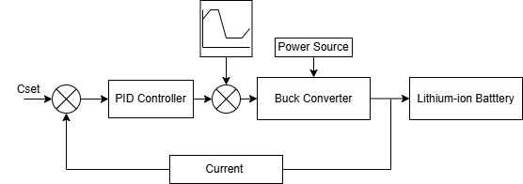
(a)
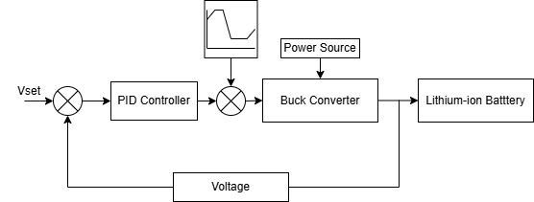
(b)
Figure 2. PID Controller Schematic: (a) Current, (b)Voltage

The charging method used is CCCV. In the CC stage, the system controls the charging current to remain constant with the help of feedback from the current sensor. Once the battery voltage reaches a certain limit, the system switches to the CV stage, where the voltage is kept stable while the current slowly decreases. Voltage control at this stage is highly dependent on the system's response to voltage feedback. By integrating the closed-loop control system and the CCCV method, the battery charging process becomes safer, more efficient, and able to extend the battery life. The flow chart of the CCCV method is shown in figure 3.

Experimental Setup
The design and testing of the charging system involves the integration between hardware and software that support each other. A prototype charger was developed specifically by embedding a PID controller inside. These controllers are implemented in the form of embedded software that runs on microcontrollers or other embedded systems. The main function of this software is to process the sensor data and provide an appropriate response to changes in voltage and temperature during the battery charging process.
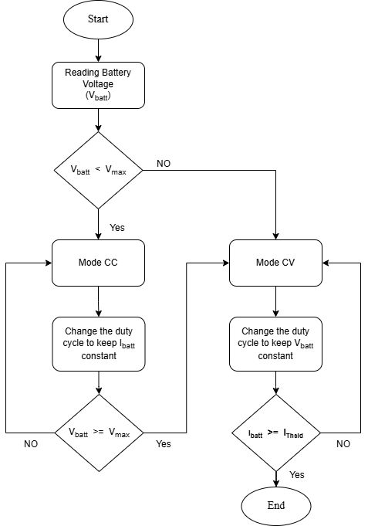
Figure 3. The Flow Chart of the CCCV Method

To thoroughly test the performance of the prototype, a series of tests were carried out using various battery models. Each type of battery has different characteristics, so it is important to ensure that the charging system is able to flexibly adjust the control parameters. Through this test, the performance of the PID controller can be evaluated, including its effectiveness in regulating current and voltage during the charging process. The results of this test are also the basis for improving the hardware and software so that the charging system is more optimal and adapts to various battery conditions. A prototype charger is developed with an embedded PID controller, and tests are conducted using different battery models. The photograph of the experimental setup of the system is shown in Figure 4.

Results and Discussion
The measurement results show in Figure 5 that the charging process occurs in three main phases that are common in PWM-based battery charging systems: bulk, absorption, and float charging. In the initial phase (0–30 minutes), the charging current is in a relatively stable high range, around 0.8 A. This indicates that the system prioritizes fast charging to efficiently fill the battery capacity. After the 30th minute, the current begins to decrease gradually until it reaches 0 A at the 90th minute, indicating the system's transition to the absorption phase and then the float phase, where charging is carried out more slowly to maintain battery life and avoid overcharging.
Meanwhile, the charging voltage shows an increasing trend from around 11.6 V to around 12.6 V. A significant increase occurs between the 30th and 35th minutes, coinciding with the decrease in current, indicating the system entering the absorption phase. After reaching the maximum point, the voltage tends to remain stable with small fluctuations, indicating precise voltage control during the charging process.
Furthermore, observation of the duty cycle strengthens the interpretation of the current and voltage behavior. The duty cycle value was initially stable at around 150%, then spiked to around 225% at the 35th minute, which was in line with the voltage spike. After that, the duty cycle decreased gradually until it reached 0% at the end of the charging process. This trend indicates that the system actively adjusts the PWM signal to control the amount of current and voltage transmitted to the battery.
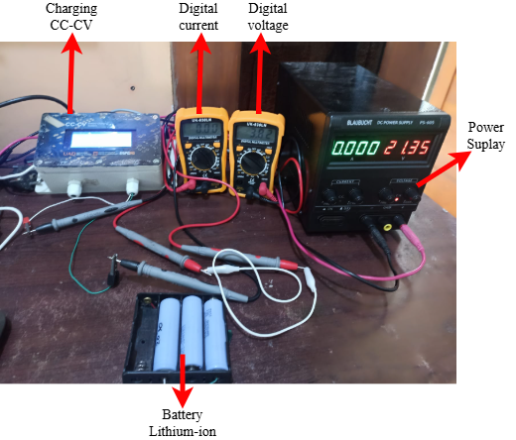
Figure 4. Experimental Setup

In general, the working pattern of the charging system recorded in the graph shows that the charging method with duty cycle control is effective in managing the charging process efficiently and safely. There are no abnormal voltage or current spikes, so it can be concluded that the system works stably and adapts to battery charging conditions.
The energy efficiency of the proposed system was evaluated by comparing the charging time and current profile with that of the conventional CCCV method. The PID-controlled charger completed the charging process in approximately 85 minutes, compared to 145 minutes for the conventional method. This reduction in charge duration reflects a more effective energy transfer process and lower idle current losses, which translates to a reduction in overall power consumption. Furthermore, stable control of the charging current during the bulk phase, without overshoot or prolonged tapering, minimizes energy waste and enhances total system efficiency.
Although temperature data was not explicitly recorded during testing, the design of the PID controller contributed to effective thermal management. The smooth transition from the CC to CV phase, without sharp current spikes, helps reduce thermal stress on the battery. Additionally, the absence of current overshoot and the gradual tapering of current imply that the system avoids sudden power surges that could cause overheating. In future work, thermal data logging will be incorporated to quantitatively validate this behavior.
The safety of the system is reinforced by the implementation of closed-loop PID control, which prevents both overcurrent and overvoltage conditions. Once the predefined voltage limit is reached, the system transitions to the CV phase, effectively stopping the current rise and avoiding overcharging. Throughout the charging process, the system maintained both voltage and current within the safe operating limits of the battery. No abnormal spikes or instability was observed in the measurements, indicating that the control mechanism ensures safe and reliable operation.

A. Performance Analysis
The results of the analysis show that the PID-controlled charging system is able to achieve a faster and more efficient charging process compared to the conventional CCCV method. On the basis of the graph, the charging current in the initial stage can be kept stably high, allowing the battery to be charged quickly in the bulk phase. Adaptive duty cycle control allows for a smooth transition to the absorption and float phases, with a gradual decrease in current and precisely controlled voltage. This not only improves charging efficiency, but also minimizes power losses. In addition, no significant voltage overshoot was detected, indicating that the PID system successfully stabilized the voltage within a safe range during the charging process. This reduction in overshoot is very important because it contributes to reducing the increase in temperature in the battery, maintaining thermal stability, and extending the service life. Thus, the PID-based charging system not only offers better energy efficiency but also improves overall battery charging safety and reliability.
The precision of the controlled voltage can be evaluated based on the voltage trend shown in Figure 5. During the CV phase, the voltage stabilizes at approximately 12.6 V with only minor fluctuations of ±0.05 V, remaining within 0.4% deviation from the setpoint. This level of deviation is considered acceptable for lithium-ion charging systems and indicates effective voltage regulation by the PID controller. The absence of any voltage overshoot throughout the charging period further confirms the accuracy of the voltage control.

Current and Voltage Stability
The stability of current and voltage are crucial factors in maintaining battery performance and longevity. The PID control system applied to the charging process has been proven to minimize temperature fluctuations by dynamically adjusting the charging current according to the real-time conditions of the battery. From the graph, it can be seen that the current gradually decreases over time, without any sharp fluctuations, indicating a stable system response to changes in charging status. This has a direct impact on the thermal stability of the battery, reducing the risk of overheating during charging.
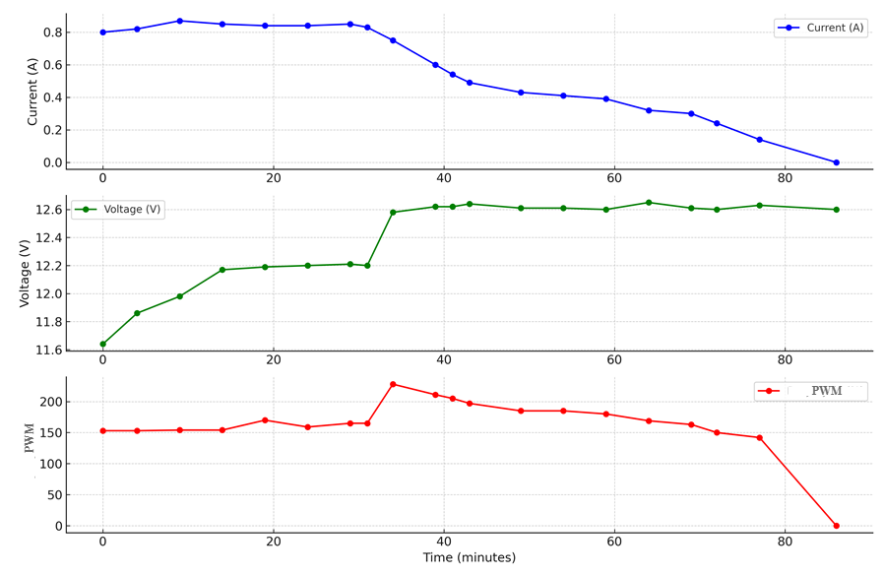
Figure 5. Graph of the Relationship Between Current, Voltage and Duty Cycle

However, the voltage is also controlled very stably. After experiencing a gradual increase at the beginning, the voltage is maintained at a safe upper limit without experiencing an overshoot. This control plays an important role in preventing overcharging, which can damage the chemical structure of the battery and reduce the cycle efficiency. With consistent voltage stabilization, the system not only maintains safety during charging but also significantly increases overall battery life.
The PID control system applied to the charging process minimizes current fluctuations by dynamically adjusting the charging current according to the real-time condition of the battery. Although temperature monitoring was not implemented in this experiment, gradual current tampering and absence of current overshoot inherently reduce the risk of thermal stress. Future studies will include integrated temperature sensing to directly validate the thermal behavior of the system.

Comparison with Conventional Methods
The comparison graph between the PID-controlled charging method and the conventional method is shown in figure 6. Significant differences in current and voltage characteristics during the battery charging process. In the left graph, it can be seen that the PID-controlled system maintains the charging current at a high level, which is around 0.85 A, for almost the first 40 minutes. In contrast, the conventional system shows a faster current decrease, starting to drop drastically after the 10th minute. This indicates that the PID-controlled system can provide a consistent charging current for a longer period of time, directly accelerating the total charging time.
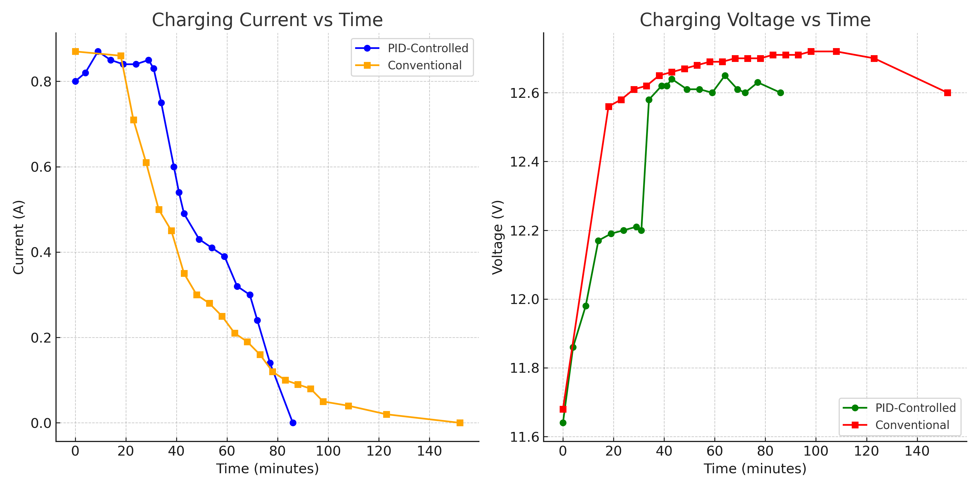
Figure 6. Graph of Comparison PID Controlled CC-CV with Conventional Charging
After the 40th minute, the current in the PID system begins to decrease gradually and ends at the 85th minute, while the conventional system takes about 145 minutes to reach zero current. This fact shows that the PID system not only charges the battery faster, but also regulates the current decrease more efficiently, which is important for maintaining the temperature and preventing battery degradation.
In the right graph, it can be seen that the charging voltage in the conventional method increases rapidly and reaches a peak above 12.7 V, even showing a tendency to overshoot before finally decreasing slightly at the end of charging. In contrast, the PID-controlled method gradually increases the voltage and keeps it stable at around 12.6 V without showing sharp spikes. This stability of voltage indicates that the PID system is more effective in controlling the charging conditions to keep them safe and within the limits of the battery specification.
In general, it can be concluded that the PID-controlled system provides better performance than the conventional method, both in terms of charging time efficiency and electrical parameter stability. With more precise current and voltage control, this system is able to maintain optimal battery conditions, extend battery life, and improve safety during the charging process.
The faster charging time observed in the PID-controlled method, as shown in Figure 6, is mainly due to the ability of the PID controller to maintain a higher and more stable charging current during the CC phase. Unlike the conventional method, which begins to reduce current prematurely or responds slowly to voltage feedback, the PID system continuously adjusts the duty cycle to keep the current closer to the setpoint until the target voltage is reached. This optimizes the rate of energy transfer in the early phase of charging. In addition, the smooth and controlled transition to the CV phase prevents unnecessary delays or oscillations, allowing the overall charging process to be completed more efficiently. This real-time regulation accelerates the bulk charging stage without compromising voltage stability or safety.

Conclusion
This study has demonstrated the effectiveness of a PID-controlled fast charging system using the CCCV method for lithium-ion batteries. The implementation of a closed-loop PID controller enabled dynamic adjustment of charging parameters, resulting in a more stable and efficient charging process compared to conventional methods. Experimental results showed that the PID-controlled system maintained a higher charging current for a longer duration, significantly reduced the total charging time, and minimized the voltage overshoot. In addition, voltage and current remained stable throughout the process, reducing thermal stress and improving battery safety.
The PID control system not only improved energy efficiency but also contributed to extending battery life by preventing overcharging and overheating. Compared to conventional CCCV charging, the proposed method showed superior current and voltage regulation performance, making it suitable for applications requiring rapid and safe charging, such as electric vehicles, portable electronics, and renewable energy storage systems. Future research may explore the integration of AI-based or adaptive control algorithms and advanced thermal management systems to further optimize performance and safety.

Declarations

Conflict of Interest
The authors have declared that no competing interests exist.

CRediT Authorship Contribution
Tole Sutikno: Conceptualization, Methodology, Supervision, Writing Review, and Editing; Tri Wahono: Software, Investigation, Data Curation; Ahmad Raditya Cahya Baswara: Formal Analysis, Validation, Visualization, Writing Original Draft.

Funding
This research was funded by Universitas Ahmad Dahlan (UAD) through Lembaga Penelitian dan Pengabdian kepada Masyarakat (LPPM) under contract number PD-214/SP3/LPPM-UAD/XI/2024.

Acknowledgment
This study is funded by a grant from Lembaga Penelitian dan Pengabdian Masyarakat (LPPM) Universitas Ahmad Dahlan, under contract number PD-214/SP3/LPPM-UAD/XI/2024. This study is also supported by Embedded Systems and Power Electronics Research Group (ESPERG).

References

[1] Y. Li, K. Li, Y. Xie, J. Liu, C. Fu, and B. Liu, “Optimized charging of lithium-ion battery for electric vehicles: Adaptive multistage constant current–constant voltage charging strategy,” Renew. Energy, vol. 146, pp. 2688–2699, Feb. 2020, doi: 10.1016/j.renene.2019.08.077.
[2] T. Sutikno, T. Wahono, and A. Ardiansyah, “A study of smart charging for electric vehicles using constant-current and constant-voltage technology,” Int. J. Adv. Appl. Sci., vol. 13, no. 3, p. 591, Sep. 2024, doi: 10.11591/ijaas.v13.i3.pp591-599.
[3] T. Shahed and A. B. M. H. Rashid, “Battery charging technologies and standards for electric vehicles : A state-of-the-art review , challenges , and future research prospects,” Energy Reports, vol. 11, no. May 2023, pp. 5978–5998, 2024, doi: 10.1016/j.egyr.2024.05.062.
[4] A. K. Koech, G. Mwandila, F. Mulolani, and P. Mwaanga, “Lithium-ion battery fundamentals and exploration of cathode materials: A review,” South African J. Chem. Eng., vol. 50, no. September, pp. 321–339, 2024, doi: 10.1016/j.sajce.2024.09.008.
[5] X. Wu, K. Zhang, Y. Chen, J. Du, and N. I. Shchurov, “Multistage fast charging optimization protocol for lithium-ion batteries based on the biogeography-based algorithm,” J. Energy Storage, vol. 52, no. PA, p. 104679, 2022, doi: 10.1016/j.est.2022.104679.
[6] H. El Ouazzani, I. El Hassani, N. Barka, and T. Masrour, “MSCC-DRL: Multi-Stage constant current based on deep reinforcement learning for fast charging of lithium ion battery,” J. Energy Storage, vol. 75, no. May 2023, p. 109695, 2024, doi: 10.1016/j.est.2023.109695.
[7] Y. Shen et al., “Online detection of lithium plating onset during constant and multistage constant current fast charging for lithium-ion batteries,” Appl. Energy, vol. 370, no. March, p. 123631, 2024, doi: 10.1016/j.apenergy.2024.123631.
[8] A. Kaleem, I. U. Khalil, S. Aslam, N. Ullah, S. Al Otaibi, and M. Algethami, “Feedback PID controller-based closed-loop fast charging of lithium-ion batteries using constant-temperature–constant-voltage method,” Electronics, vol. 10, no. 22, Art. no. 2872, 2021, doi: 10.3390/electronics10222872.
[9] A. Haraz, K. Abualsaud, and A. Massoud, “State-of-Health and State-of-Charge Estimation in Electric Vehicles Batteries : A Survey on Machine Learning Approaches,” IEEE Access, vol. 12, no. September, pp. 158110–158139, 2024, doi: 10.1109/ACCESS.2024.3486989.
[10] G. Yang, “State of Charge Estimation of Lithium-Ion Battery for Underwater Vehicles Using MM-UKF Under Hierarchical Temperature Compensation,” IEEE Access, vol. 12, no. July, pp. 95831–95845, 2024, doi: 10.1109/ACCESS.2024.3425950.
[11] X. Wang, Y. Tang, Z. Li, and C. Xu, “Research on charging strategy based on improved particle swarm optimization PID algorithm,” Complex Intell. Syst., vol. 10, no. 5, pp. 6421–6433, 2024.
[12] A. Rospawan and J. W. Simatupang, “Microcontroller-Based Lead-Acid Battery Balancing System for Electric Vehicle Applications,” J. Elektron. dan Telekomun., vol. 21, no. 2, p. 128, 2021, doi: 10.14203/jet.v21.128-139.
[13] O. F. Nami et al., “Performance Comparison of PID, FOPID, and NN-PID Controller for AUV Steering Problem,” J. Elektron. dan Telekomun., vol. 24, no. 1, p. 72, 2024, doi: 10.55981/jet.596.
[14] M. Usman Tahir, A. Sangwongwanich, D. I. Stroe, and F. Blaabjerg, “Overview of multi-stage charging strategies for Li-ion batteries,” J. Energy Chem., vol. 84, pp. 228–241, 2023, doi: 10.1016/j.jechem.2023.05.023.
[15] M. S. H. Lipu et al., “Real-Time State of Charge Estimation of Lithium-Ion Batteries Using Optimized Random Forest Regression Algorithm,” IEEE Trans. Intell. Veh., vol. 8, no. 1, pp. 639–648, 2023, doi: 10.1109/TIV.2022.3161301.
[16] X. Sun, Z. Li, X. Wang, and C. Li, “Technology development of electric vehicles: A review,” Energies, vol. 13, no. 1, pp. 1–29, 2019, doi: 10.3390/en13010090.
[17] M. Brenna, F. Foiadelli, C. Leone, and M. Longo, “Electric Vehicles Charging Technology Review and Optimal Size Estimation,” J. Electr. Eng. Technol., vol. 15, no. 6, pp. 2539–2552, Nov. 2020, doi: 10.1007/s42835-020-00547-x.
[18] G. Zhao, Y. Wang, and Z. Chen, “Health-aware multi-stage charging strategy for lithium-ion batteries based on whale optimization algorithm,” J. Energy Storage, vol. 55, no. PC, p. 105620, 2022, doi: 10.1016/j.est.2022.105620.
[19] Q. Y. Huang, Y. H. Liu, G. J. Chen, Y. F. Luo, and C. L. Liu, “Optimization of the SOC-based multi-stage constant current charging strategy using coyote optimization algorithm,” J. Energy Storage, vol. 77, no. August 2023, p. 109867, 2024, doi: 10.1016/j.est.2023.109867.
[20] Z. Mahdavi et al., “Providing a Control System for Charging Electric Vehicles Using ANFIS,” Int. Trans. Electr. Energy Syst., vol. 2024, 2024, doi: 10.1155/2024/9921062.
[21] S. S. Rad et al., “A Novel Approach in Evaluating Battery Charger Controller Design with Nonlinear PID Controller for an Extendable CHIL Setup,” in 2024 IEEE Transportation Electrification Conference and Expo (ITEC), 2024, pp. 1–5.
[22] L. H. Fang, M. I. F. Romli, R. A. Rahim, M. E. A. Aziz, D. H. A. Rahman, and H. H. Mokhtaruddin, “Development of an advanced current mode charging control strategy system for electric vehicle batteries,” Int. J. Power Electron. Drive Syst., vol. 15, no. 4, p. 2639, Dec. 2024, doi: 10.11591/ijpeds.v15.i4.pp2639-2650.
[23] B. T. Gul and I. Ahmad, “Optimized ANFIS-Based Robust Nonlinear Control of a Solar Off-Grid Charging Station for Electric Vehicles,” IEEE Access, vol. 13, no. December 2024, pp. 20361–20373, 2025, doi: 10.1109/ACCESS.2025.3535571.
[24] N. D. Tuyen, N. V. M. Tam, and T. P. Hoa, “LCL filter based high power density AC/DC converter for fast charging applications,” Int. J. Power Electron. Drive Syst., vol. 15, no. 4, p. 2308, Dec. 2024, doi: 10.11591/ijpeds.v15.i4.pp2308-2322.
[25] F. D. Murdianto, I. Sudiharto, and A. F. Andraeni, “Active balancing charging using ANFIS to reach longest lifetime for lithium ion,” Int. J. Power Electron. Drive Syst., vol. 15, no. 4, p. 2168, Dec. 2024, doi: 10.11591/ijpeds.v15.i4.pp2168-2179.
[26] M. U. Tahir, A. Sangwongwanich, D. I. Stroe, and F. Blaabjerg, “Multi-objective optimization for multi-stage constant current charging for Li-ion batteries,” J. Energy Storage, vol. 86, no. PA, p. 111313, 2024, doi: 10.1016/j.est.2024.111313.
[27] Y. Du, Z. Zhang, Z. Zuo, and Y. Wang, “Lithium battery charging optimization via multi-stage combined charging strategy in solar-powered vehicles,” J. Energy Storage, vol. 83, no. January, p. 110716, 2024, doi: 10.1016/j.est.2024.110716.
[28] M. Irwanto et al., “Photovoltaic powered DC-DC boost converter based on PID controller for battery charging system,” in Journal of Physics: Conference Series, 2020, vol. 1432, no. 1, p. 12055.

