Interference Management Using Distance-based Clustering Method for D2D Communication Underlaying Multicell Cellular Network

Soraida Sabella, Misfa Susanto*, FX Arinto Setyawan
Department of Electrical Engineering
University of Lampung
Jl. Sumantri Brojonegoro No. 1
Bandar Lampung, Indonesia

Abstract
Device-to-device (D2D) communication is a technology candidate to support the next generation of cellular communication networks. D2D can potentially boost the efficiency of frequency resources and system capacity. Generally, D2D performs in-band underlaying or shares frequency channels with traditional cellular users, which can cause co-channel interference problems between these two types of users. This paper offers a solution through a clustering method for D2D users (DUEs) to reduce interference among DUEs. The clustering method is performed on DUEs by allocating different frequency channels in a group, in order to minimize the interference effects experienced. Thus, it is expected that through this proposed method, both D2D and cellular users can experience better signal quality with minimal interference effects. Two systems have been considered i.e., the conventional/baseline system and the system with the proposed method. The simulation results show that the signal-to-interference-plus-noise ratio (SINR) values and throughput for the system with the proposed method have increased compared to the baseline system. The SINR result obtained is 16.8 dB for the baseline system and 17.68 dB for the proposed system, resulting in an improvement of 5.4%. Therefore, applying the proposed clustering method can increase the acceptability of the desired signals for the observed DUEs. Then, the throughput value also increases by 5%, i.e., from 56.17 to 59 Mbps. This result implies that the system with the proposed clustering method increases data transmission speed better than the baseline system.

Keywords: D2D communication, in-band underlay, multicell, clustering, downlink transmission.

Introduction
Telecommunications services have matured significantly in recent years, particularly regarding cellular data traffic. This happened due to the exponential increase in the use of smartphones and other portable devices that provide voice, data, and multimedia services [1], [2]. The fifth generation (5G) of cellular technology has now started to influence industry, while the sixth generation (6G) research has also been initiated. For these reasons, people expect technology that can keep up with the ascending demand for services. Data speeds, spectral efficiency, power consumption, and other benefits in crowded mobile communication networks can all be enhanced by device-to-device communications (D2D communication), according to a study in [3]–[5]. D2D communication consists of two-user pairs, which can communicate directly without going through a base station (BS) as a transceiver (transmitter and receiver) station [6]. The implementation of the D2D network will contribute to the future commercial D2D communications for mobile systems in addition to essential and emergency communications, such as public safety communications [7], close proximity services [8], etc.
* Corresponding Author.
Email: misfa@eng.unila.ac.id
Received: August 28, 2023 ; Revised: November 15, 2023
Accepted: November 20, 2023 ; Published: December 31, 2023

Open access under CC-BY-NC-SA
© 2023 BRIN
25-32

Figure 1. Frequency spectrum division of in-band underlay and overlay of D2D.
In enabling D2D communications into wireless cellular communications, D2D communications share the frequency spectrums with existing cellular communications, which is referred to as in-band D2D. There are two types of spectrum usage for in-band D2D communications. Figure 1 shows the division of the spectrum into two types for in-band D2D communications. The majority of D2D-related literature suggests separating cellular spectrum uses for D2D users and cellular communication users (commonly referred to as in-band D2D). Underlay in-band D2D, which divides the frequency channels with cellular users in order to conserve the frequency spectrum, will cause interferences [9], [10]. Some literature suggests reserving a portion of cellular resources (in-band overlay D2D) just for D2D communication in order to prevent interference issues [11], [12]. Resource allocation becomes very important so that dedicated mobile resources are not wasted. Other researchers proposed adopting out-band D2D communication instead of in-band in cellular networks so that the valuable cellular frequency spectrum is not affected by D2D communication [13]. However, most of the literature that suggests out-band D2D communications proposes the usage of ISM (industrial, scientific, and medical) frequency spectrum [14], [15]. The ISM band is best known as the crowded frequency spectrum due to the unlicensed feature of the ISM band [16].

This paper focuses on the D2D in-band underlay. D2D communication shares a similar frequency bandwidth with cellular users [17], so even though the implementation of D2D communication provides various advantages, it also creates interference due to the use of the same frequency bandwidth. Furthermore, the more D2D users spread across a network, the heavier the interferences that D2D user pairs and cellular users suffer [18]. Due to this reason, a solution is required to address the issues caused by the existence of D2D users. Thus, this paper proposes a clustering method for D2D users to reduce the interference effects among D2D communication pairs. Clustering is a method for grouping users deployed across a cellular network. The clustering method is applied to D2D users assigned to different frequency channels to form a cluster to reduce interference among other nearby D2D users. A similar pattern of the frequency channel assignments is replicated in other clusters. By this intuition, it is expected that the interferences’ effects among the D2D communications pairs will be lowered and the performance improvements for D2D communications will remain satisfactory.
[1], [3], [8], [19] apply the cluster Poisson process (PCP) for D2D clustering modeling, meanwhile [10] applies the spatial homogeneous point Poisson process (SPPP) for authentication modeling correlation between D2D nodes. [7] applies two clustering methods in D2D, namely random-based clustering (RBC) and channel-gain-based clustering (CGBC). [20], [21] focus on using cluster head (CH) selection and K-means algorithm, respectively, to maximize energy efficiency and minimize interference from multicast D2D networks. [22] uses interference-aware graph-based user clustering. However, these aforementioned clustering methods face more complex methods in the calculation analysis and algorithm implementation. Our paper proposes another simple clustering method, namely distance-based clustering. This proposed clustering method groups a number of adjacent D2D users forming a cluster and there will be many clusters in the considered system. In a cluster, a D2D user and its pair establishing a D2D pair are assigned a frequency channel when communicating. Furthermore, each D2D pair in a cluster is assigned a different frequency channel to other D2D pairs, thus there should be no interference among D2D pairs in a cluster. This frequency channel assignment procedure is repeated for all clusters. Among the clusters, a designed frequency reuse factor is applied. Our proposed clustering method assures that no adjacent D2D pairs are assigned the same frequency channels, reducing the effects of co-channel interferences among D2D users.
The rest of this paper is structured as follows. Following this introduction section, the methodology is presented in Section 2. Section 2 describes the proposed clustering method, cellular network scenarios used in the analysis, and simulation parameters. Section 3 presents the results and its discussions. The results and discussion section deliberate about the results of a comparison of the systems without and with the proposed method by calculating the signal-to-interference plus noise ratio (SINR), throughput, and cumulative distribution function (CDF) values. This paper is concluded in Section 4.

Methodology
This paper considers cellular communication networks with two types of users: cellular users (CUE/cellular user equipment) and D2D-communication users (DUE/D2D communication user equipment). Cellular communication networks are considered at downlink transmissions and are applied orthogonal frequency division multiple access (OFDMA). There are two scenarios of considered cellular communication networks. The first scenario is a cellular communication network consisting of three microcells that are applied a frequency reuse factor (FRF) value of 1. D2D users use the same frequency channel as applied for CUEs (underlay in-band frequency). DUE and CUE are randomly distributed following a uniform distribution at downlink transmission of traditional cellular communications. Thus, both CUE and DUE will suffer interferences due to the use of the same frequency channel caused by ENodeBs (evolved node B) or other DUEs’ transmitters, since DUEs share a frequency channel with CUEs (in-band underlay D2D) in this paper. Note that in this first scenario, the usage of frequency channels for D2D communications is assigned randomly following FRF of 3. The second network scenario is the system of the first scenario that is applied to a proposed clustering scheme. The proposed clustering scheme is discussed in a sub-section of this section.
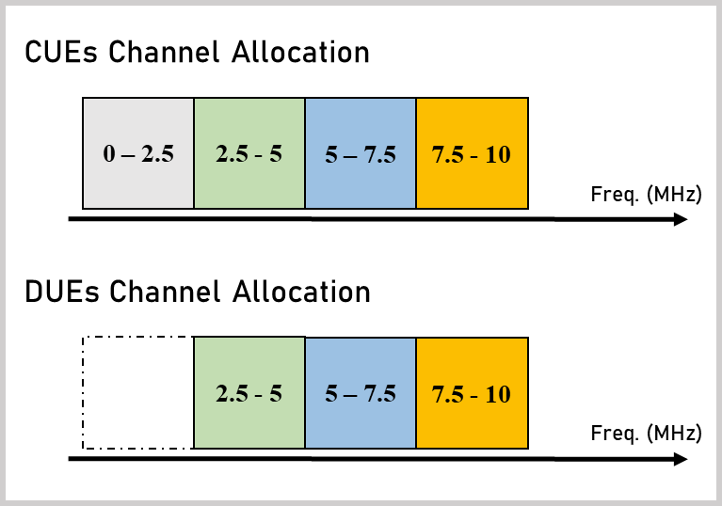
Figure 2. Frequency channel allocations for DUEs and CUEs.

All network scenarios follow a sub-bandwidth assignment which is designed in this paper according to the network scenario. Figure 2 represents the frequency spectrum division that is allocated for the two types of users. We set a system bandwidth of 10 MHz and then divide the total channel into four sub-channels. It should be noted that DUEs are allocated 75 percent of the total channel, and CUEs are assigned to use the entire total bandwidth. It is purposed for protecting a portion of CUEs from the interferences caused by the DUEs. Note also that the sub-bandwidth allocations for CUEs and DUEs in Figure 2 are for the clarity of discussions in the next sub-section applying the frequency channel assignments in the proposed clustering scheme.

The Traditional Versus Proposed Clustering Method Network Scenarios
Figure 3 shows a scenario of a multicell of wireless cellular communication network in the presence of DUEs and CUEs. Since DUEs and CUEs share the same frequency spectrum, there is an advantage to sharing a frequency channel, i.e., the use of the channel for the whole system becomes more efficient. However, it should also be noted that sharing channels between the two types of users will result in co-channel interferences or interferences caused by the use of the same channel. In Figure 3, the frequency channel assignments follow the sub-bandwidth allocations in Figure 2 for each cell. Moreover, the assignments of frequency channels for DUE do not consider the locations of DUEs. It is assigned according to the presence of DUEs. Then, it can be noticed that the DUEs likely experience a decrease in signal quality due to the presence of other DUEs that use the same channel and are close to one another. Therefore, a solution is needed to suppress such co-channel interferences on the DUEs’ side.
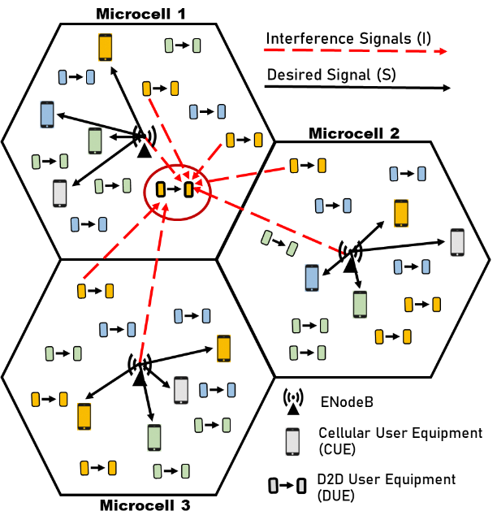
Figure 3. Traditional cellular network scenario.

A clustering method is proposed in this paper to minimize interference effects suffered by DUEs, especially interferences caused by other DUEs. This clustering method will be implemented for the DUEs side. The clustering method works by adjusting the DUE channel allocations of a group of three DUE pairs with different frequency channels, as illustrated in Figure 4. It means that we apply FRF of 3 for DUE clusters. This method is proposed to keep D2D users away using the same frequency channels from one to another.
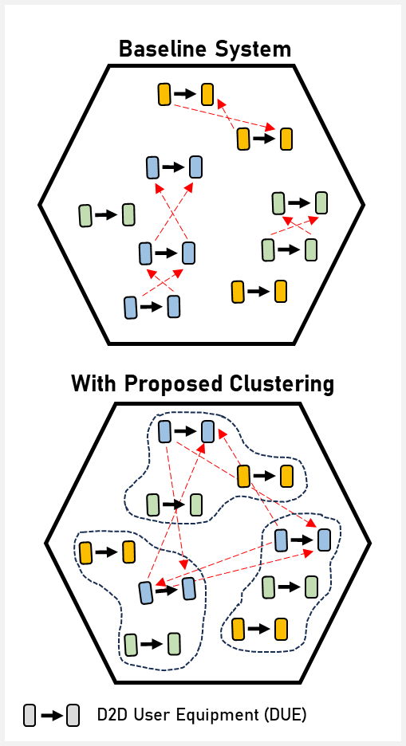
Figure 4. The proposed clustering method.

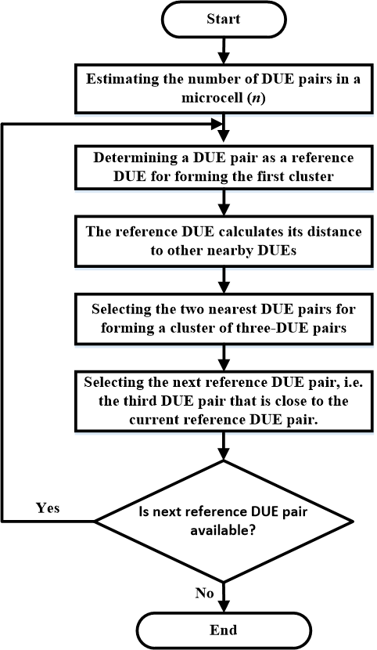
Figure 5. The flowchart of the proposed clustering method.

The clustering method works by first determining a DUE pair as a reference to form a cluster. This reference DUE pair then calculates its distance to other nearby DUE pairs. The two nearest DUE pairs from the reference DUE pair are selected as cluster members. So, it forms three DUE pairs as a cluster. Having determined a cluster, the previously referenced DUE pair will select the next DUE pair as the next reference DUE pair. The following reference DUE pair is selected from the third DUE pair close to it. Having selected the next reference DUE pair, the algorithm of forming a cluster repeats until the last DUE pair reaches a microcell area. Figure 5 depicts the flowchart of proposed DUEs cluster formation that is illustrated in Figure 4. The channel allocations in a cluster follow the channel allocations shown at the bottom of Figure 2.
From Figure 4, it can be seen that after the clustering method is applied, the distance between DUE pairs that use the same frequency channel becomes farther away, reducing co-channel interference (interference from using the same channel among D2D pairs). In other words, the clustering method that will be used is based on the distance between the scattered DUEs, so that it will decrease the possibility of co-channel interferences that will occur. The implementation of the proposed clustering method in the simulation scenario is illustrated in Figure 6.

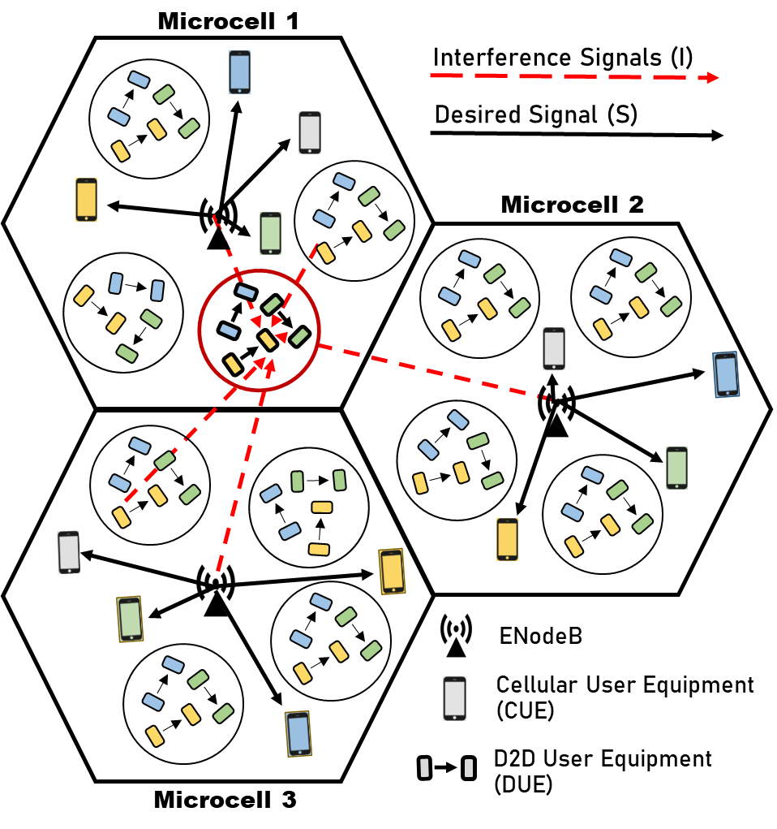
Figure 6. Cellular network scenario with clustering method.

System Model and Performance Analysis
We simulate two network scenarios of three microcellular networks with FRF of 1 that are earlier described. The radius of each microcell is set to 500 meters. In the simulation experiment, the number of DUE pairs and the number of CUEs deployed in the networks are 120 each in each microcell. All of them are randomly deployed following a uniform distribution. The distance between the D2D pair is set to 10 meters. The transmit power of ENodeB applied to the microcell is 40 dBm and the transmit power of the DUE transmitter is 23 dBm. The total system bandwidth is set to 10 MHz. Noise power spectral density is set to -174 dBm/Hz. The simulation experiment is run 5,000 times, and the performance parameters i.e., SINR and throughput, are collected for each simulation run. These performance parameters are averaged for 5,000 times of simulation runs. Table 1 summarizes the simulation parameters.
In this paper, we consider channel losses caused just by the distance between transmitter and receiver i.e., path loss. Since the network scenario consists of traditional cellular and D2D communications, there are two path-loss models applied in the network scenarios: the path-loss of CUE ($β_{CUE}$) in (1) [23] and the path-loss of DUE ($β_{DUE}$) in (2) [24]. The path losses in these models are represented in the values in dB units, with distances between CUE ($a_{CUE}$) and DUE ($a_{DUE}$) in kilometers.

$β_{CUE}=140.7+36.7*\log{(a_{CUE})}$ (1)

$β_{DUE}=148+40*\log{(a_{DUE})}$ (2)
The calculation of path loss will be used to calculate the value of the received power, both for the desired signal power and the interference signal powers at the CUEs and DUEs in which SINR calculation depends on these received powers. So it influences the calculation of throughput. The expected receive power and the interference powers can be measured using (3).
$P_{rx}\left(dBm\right)=P_{tx}\left(dBm\right)-β (dB)$ (3)
where $P_{rx}$ denote the expected receive power in dBm by the observed DUE or CUE, $P_{tx}$is the transmitted power by ENodeB or DUE transmitter, and $β$ is the path-loss in dB unit ($β_{CUE}$ or $β_{DUE}$).
Table 1
Parameters Setting
No. | Parameter | Value
1 | The number of microcells | 3
2 | Frequency reuse factor of microcells | 1
3 | Microcells radius [27] | 500 meters
4 | ENodeB transmits power [23] | 40 dBm
5 | Transmit power of DUE transmitter | 23 dBm
6 | DUE pair distance [24] | 10 meters
7 | Number of CUE (each microcell) | 120 users
8 | Number of DUE pairs (each microcell) | 120 users
9 | System Bandwidth | 10 MHz
10 | Noise Power [28] | -174 dBm/Hz
11 | Simulation iterations | 5,000

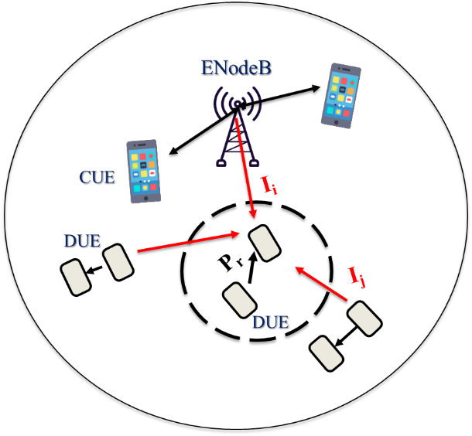
Figure 7. DUEs’ analysis of cellular network scenarios.

Figure 7 is an illustration of the observed DUE receiving the expected signal and interference signals from other transmitters (other DUEs and ENodeBs). The SINR for CUE, $γ_{CUE}$, and SINR for DUE, $γ_{DUE}$, are obtained from the interference scenario illustrated in Figures 3 and 6 so that SINR can be obtained from (4) and (5).
$γ_{CUE}= \frac{P_{r_CUE}}{\sum_{i=1}^{x}{I_{i }} + \sum_{j=1}^{y}{I_{j}} + P_{N}}$ (4)
$γ_{DUE}= \frac{P_{r_DUE}}{\sum_{i=1}^{x}{I_{i }}+ \sum_{j=1}^{y}{I_{j}} + P_{N}}$ (5)
where $P_{r_CUE}$ and $P_{r_DUE}$ denote the received powers in mWatt of the observed CUE and DUE receivers, respectively, $I_{i }$ represents the i-th interference caused by ENodeB, and $I_{j }$ represents the j-th interference caused by another DUE transmitter, and $P_{N}$ is the noise power in the network system. Meanwhile, the throughputs of CUEs ($r_{CUE}$) and DUEs ($r_{DUE}$) by using bandwidth ($Bw$) of 10 MHz are determined in (6) and (7) [25].

rCUE bps= Bw*log2 (1+γCUE) (6)
rDUE bps= Bw*log2 (1+γDUE) (7)

γCUE= Pr_CUEi=1xIi + j=1yIj + PN

rCUE bps= Bw*log2 (1+γCUE)
rDUE bps= Bw*log2 (1+γDUE)
The flowchart of the simulation program carried out in this paper is shown in Figure 8. The first step is to set the simulation parameters such as the coordinates of the EnodeB microcell, the number of EnodeBs and DUEs, transmit powers of DUE transmitters and ENodeBs, the system bandwidth that is being used, etc, according to the simulation parameters in Table 1 and described previously. Then, DUEs and CUEs are distributed randomly following a uniform distribution. As a control link, EnodeB assigns frequency channels accordingly to DUEs using the clustering method. It then determines the power expected by the DUE receiver from its pair, i.e. its corresponding DUE transmitter. Then, the simulation calculates the interference and noise power received by the DUE. The final step is calculating SINR and throughput determined during simulation iterations and its average values and then analyzing the results.
Figure 8. The flowchart of the simulation program.

By determining the performance metrics of SINR and throughput, we can identify outage probability for the considered network scenario. Outage probability can be obtained by analyzing the cumulative distribution function (CDF) of the random variables of SINR and throughput. It is depicted in (8) [26].
$CDF\left(X\right)=Prob(X≤x)$ (8)
This CDF represents that the probability of a random variable X takes a value less than or equal to x. In this case, the random variables in our analysis are SINR or throughput.

Results and Discussion
This paper compares the performance parameters of SINR and throughput between the systems without and with the proposed clustering method. The system without the clustering method is called the baseline system in this paper. CDF results for SINR and throughput are also displayed in this paper to see the distribution of the obtained simulation results. Hence, the outage probability can be analyzed. This analysis focuses on the increase in the number of CUE and DUE receivers. It should be noted that the proposed clustering method only applies to the D2D communication side. The CUE performance analysis is carried out also in this paper for the purpose of a comparison to perceive the effects of applying the proposed clustering method to D2D communications that are deployed in wireless cellular networks.

Analysis of DUE Performances
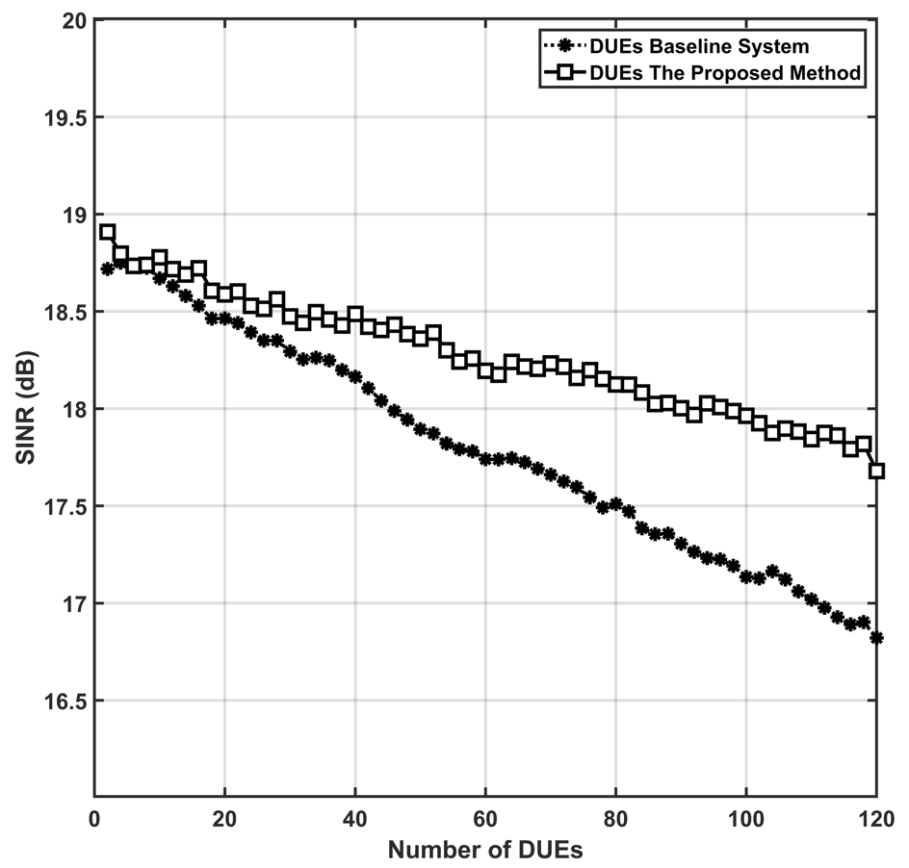
Figure 9. The SINR simulation results for DUEs.

Figure 9 shows the results of the comparison of the SINR value to the increase of the number of DUEs for two considered network scenarios i.e., the scenario for the baseline system and the scenario for the system with the proposed clustering method. It can be seen that the value of SINR decreases as the number of DUEs that are deployed increases. The SINR value for the baseline system with the number of DUE pairs equal to 120 reaches 16.8 dB. Meanwhile, the system with the proposed method obtains the SINR value of 17.7 dB. It can be said that the system with the proposed clustering method is able to increase the SINR value with an improvement of 5.4%. It implies that the proposed clustering method can guarantee the distance of DUE pairs that are allocated the same frequency channel away from one to another and even the number of DUE pairs is high creating dense D2D pairs deployed in the system.

The CDF value for SINR obtained from Figure 9 is depicted in Figure 10. The graph shows in detail that there is a fairly large gap in SINR values between the two systems. When we consider the SINR value of 18 dB, the results show that when the SINR value that is less than or equal to 18 dB for the baseline system reaches 60%, the system with the proposed method obtains a CDF value of 24%. It implies that the baseline system has a higher outage probability compared to the system with the proposed clustering method.
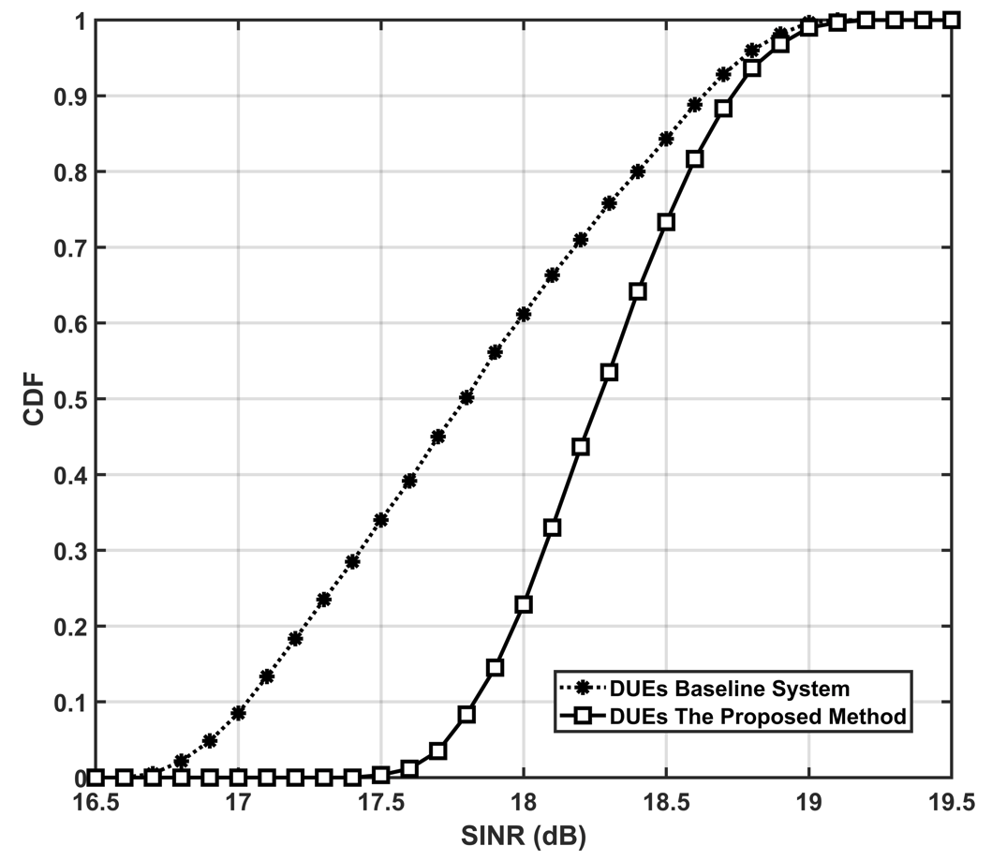
Figure 10. The CDF of SINR simulation results for DUEs.

Figure 11 is the result of the throughput values obtained from the simulation for two systems. Overall, the throughput value obtained has the same trendline as the previous SINR results. Therefore, the proposed method provides a better value than the baseline system. For the baseline system, the final throughput obtained is 56.17 Mbps, whereas, for the system with the proposed clustering method, the throughput value is 59 Mbps, both evaluated when the number of D2D pairs is 120. It means a 5% improvement. The CDFs of the throughput are described in Figure 12. The throughput value which is less than or equal to 60 Mbps for the baseline system and the system with the proposed clustering method is 60% and 22.5%, respectively. Similar implications as in the SINR performance results apply to the throughput performances. So, it can be concluded that the proposed clustering method provides a better delivery of transmission rate than the baseline system. However, our clustering method does not consider the mobility of DUEs. Regarding mobility, our clustering method needs to re-form the cluster, which increases the complexity and power of algorithm calculations.
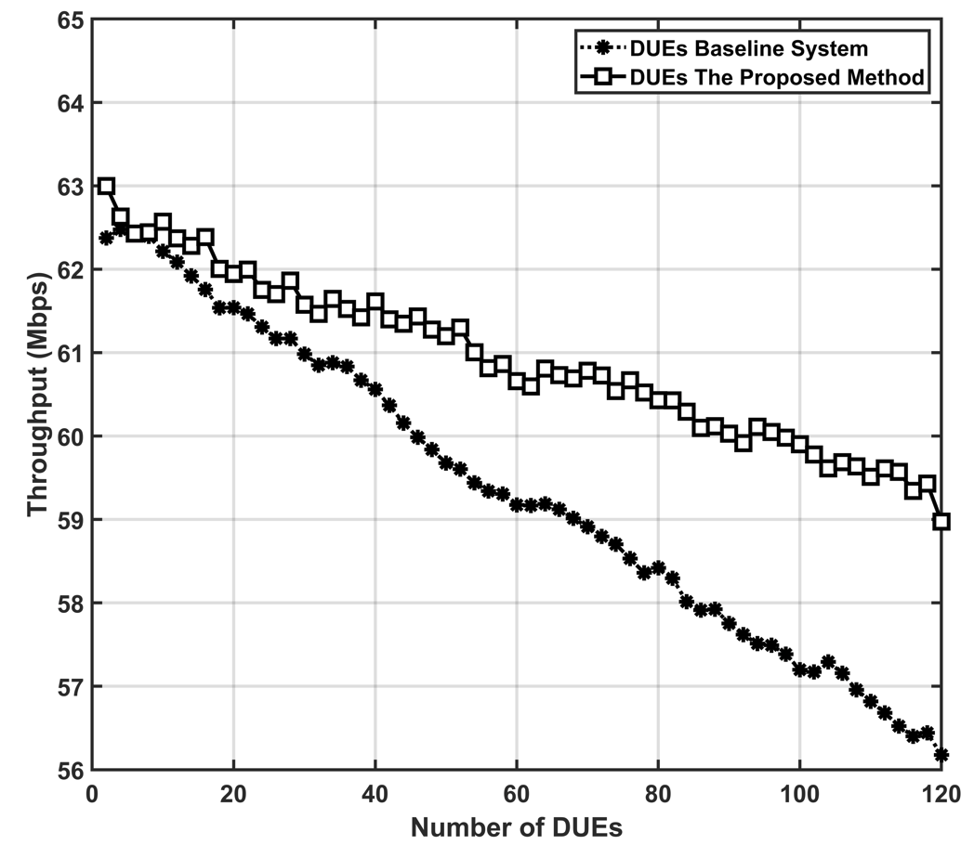
Figure 11. The throughput simulation results for DUEs.
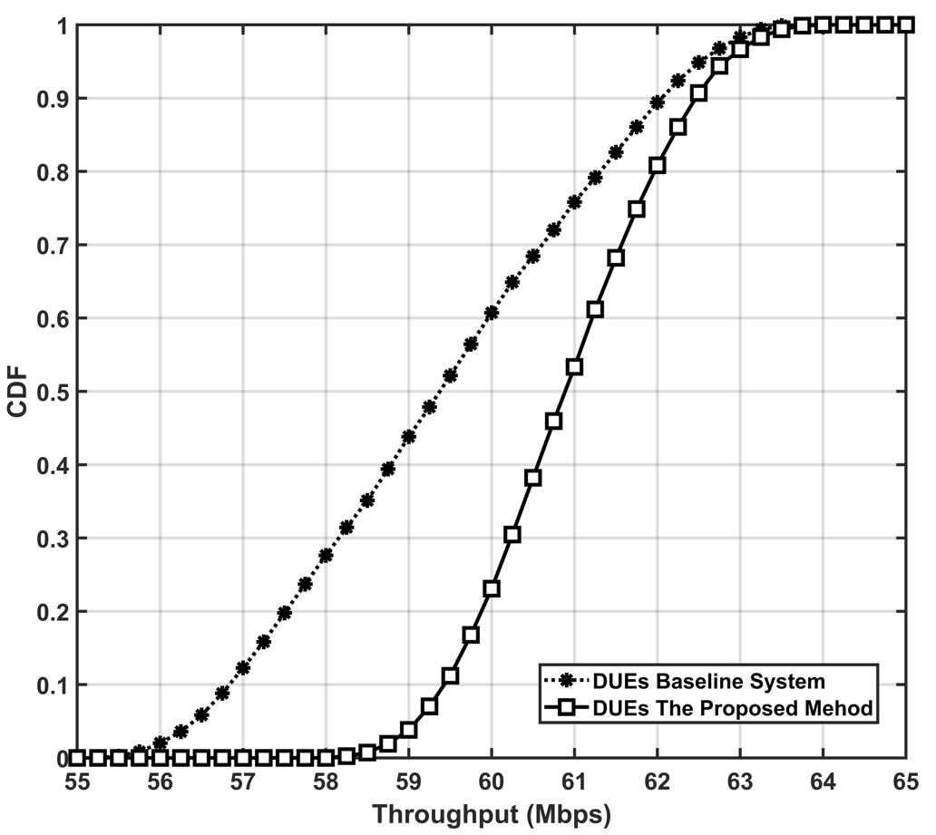
Figure 12. The CDF of throughput simulation results for DUEs.

Analysis of CUE Performances
Figure 13 shows the simulation results for comparing the SINR values received by CUEs due to the presence of DUE in the network scenarios, by analyzing the two network systems. The simulation results obtained are that the SINR value for the system with the proposed
clustering method has slightly decreased compared to the baseline system. The SINR results for the number of 120 CUEs are 28.4 dB for the baseline system and 26.8 dB for the system with the proposed clustering method. Even though applying the proposed clustering method decreases the SINR value for CUE, the decrease given is not too significant and the value obtained can still provide good signal quality for CUE. It means that by enabling D2Ds, the performances of CUEs are not degraded much. Moreover, with the proposed clustering method, the network still serves the CUEs with good performances.

The CDF values for the SINR of CUEs are shown in Figure 14. Overall, the resulting graphs have a slight gap between the values. For the system with the proposed method, the CDF value obtained is 42.5% and for the baseline system, it is 47.5%. Both are evaluated for a SINR value of less than or equal to 30 dB. The SINR values obtained between the two systems are still quite good even though there are DUEs that contribute co-channel interferences to CUEs.
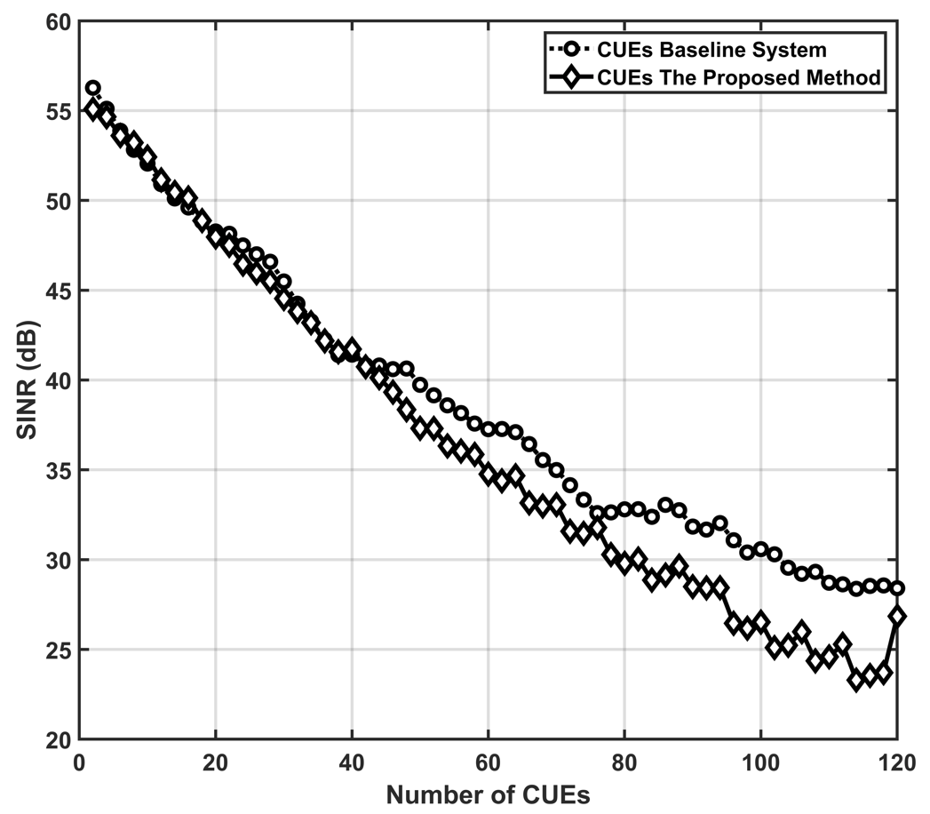
Figure 13. The SINR simulation results for CUEs.

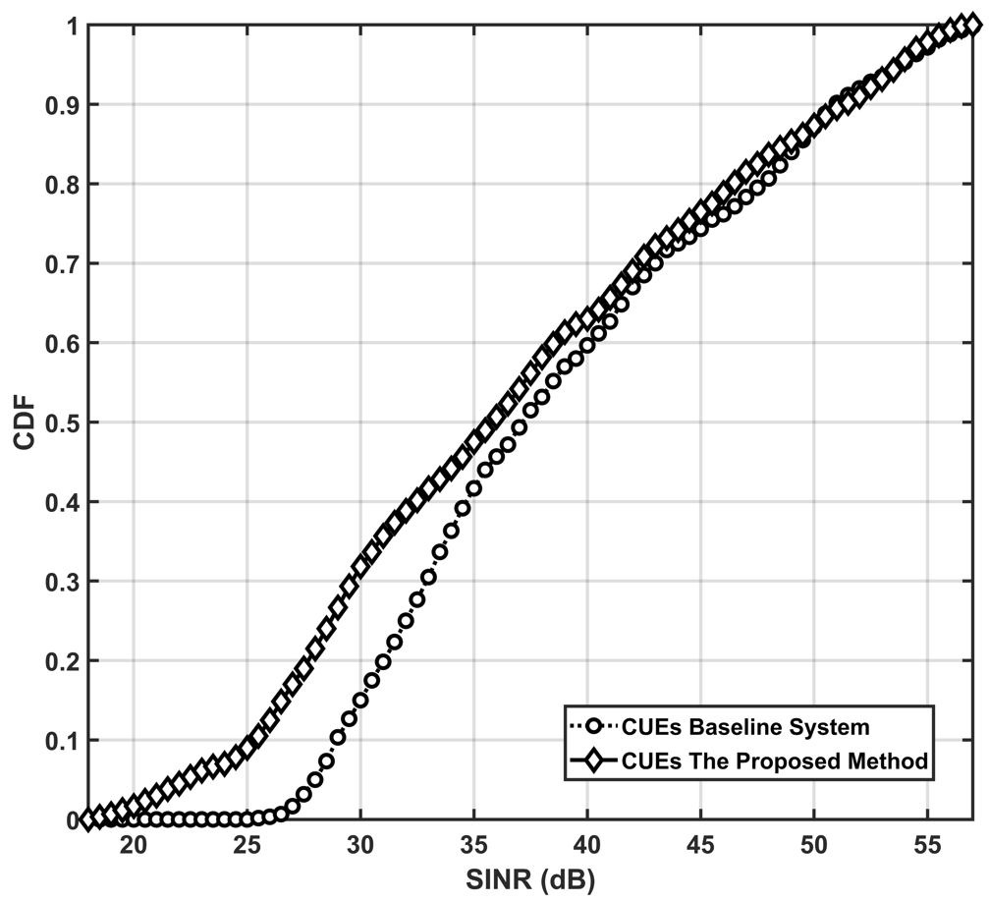
Figure 14. The CDF of SINR simulation results for CUEs.

For analysis of the throughput, simulation results obtained by CUEs are shown in Figure 15. The throughput values are directly proportional to the SINR which has been described previously. The throughput of the baseline system is slightly superior compared to the throughput of the system with the proposed clustering method. The throughput values obtained for the two systems include 94 Mbps for the baseline system and 89.2 Mbps for the system with the proposed clustering method. It implies that our proposed clustering method works well without the significant degradation of CUE performances.
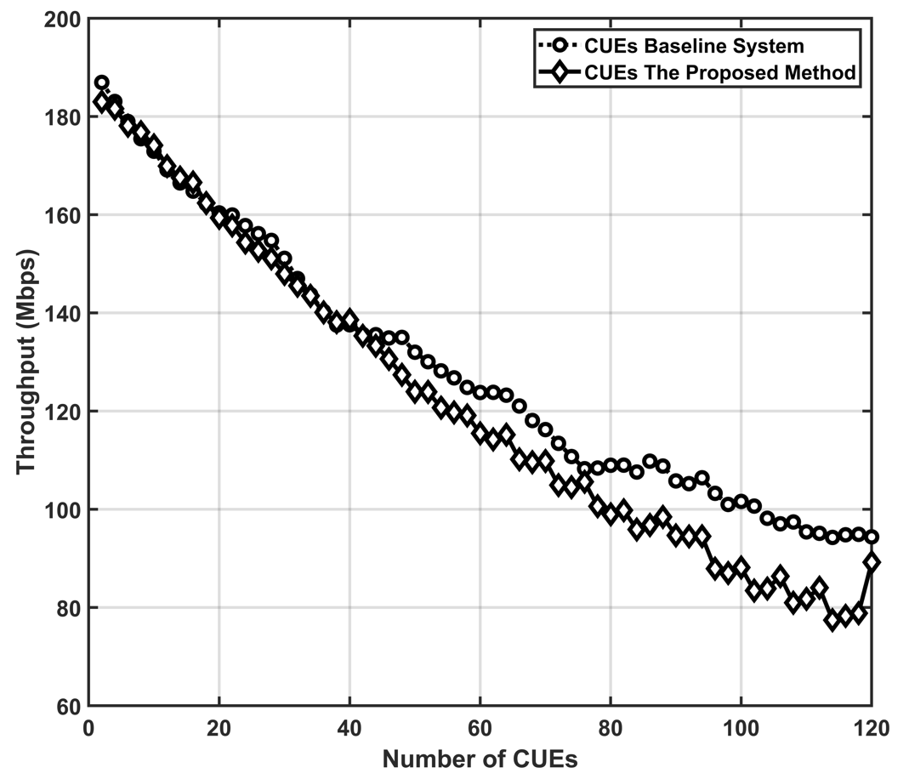
Figure 15. The throughput simulation results for CUEs.
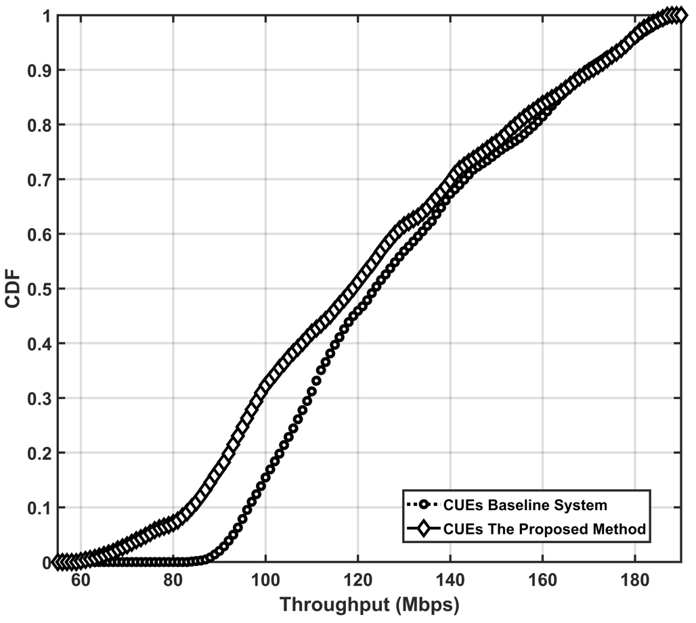
Figure 16. The CDF of throughput simulation results for CUEs.
The CDF values of the throughput obtained by both systems are depicted in Figure 16. When the throughput is less than or equal to 120 Mbps, the results obtained for the two systems include 45% for the baseline system and 50.8% for the system with the proposed clustering method. The throughput simulation results for CUE are quite good for both systems.
A comparison of the results from other related works available in the literature is presented in Table 2. Our paper simulates a multicell scenario with downlink transmission by analyzing two types of users (DUE and CUE) which it is our contributions. Based on the simulation, the proposed clustering method is able to increase the SINR value with an improvement of 5.4%.

Conclusion
Deployment of DUE in a cellular network provides a good advantage in network systems because this technology promises better frequency channel efficiency and has the potential to support higher-level communication technologies. However, enabling D2D faces interference problems. This paper proposes a clustering method on the D2D side to reduce the interference effects. The proposed clustering method can suppress interference that occurs in cellular networks, especially interference received from other DUEs i.e., co-channel interferences, and is close to the DUE being observed. The simulation results show that the comparison of the SINR values between the baseline system and the system with the proposed clustering method has increased by 5.4% from 16.8 to 17.68 dB, and the throughput value has increased from 56.17 to 59 Mbps i.e., an improvement of 5%. Since the proposed clustering method focuses on reducing interference effects at the D2D side (DUE), it is suggested to consider reducing the interferences at the DUE and CUE sides. As our clustering method does not consider mobility for DUEs, it is possible to consider mobility since it needs to re-form the cluster and it increases the calculation complexity. As other clustering methods are available in the literature, it is beneficial to compare our proposed clustering method to other clustering methods in the literature in terms of simulation experiments.

Table 2
The Comparison to Previous Research Results
Ref. | Methods | Results
[7] | D2D with Random-Based Clustering (RBC) and Channel-Gain-Based Clustering (CGBC) schemes | The proposed method is able to reduce the delay to less than 20 ms.
[10] | The proposed method by setting the clustering size from users | Networks with smaller clusters achieve large gains but experience a bit of delay
[19] | In-band communication with cluster Poisson under a cluster-centric caching strategy | The cluster-centric caching strategy increases the probability of a cache hit of DUEs up to 80% for the number of requests.
[21] | Users clustering in a D2D multicast content-sharing scenario | The proposed scheme reaches the energy efficiency of up to 7%.
[22] | Clustering methods based on graph-based interference and k-means clustering | The graph-based interference method increases the spectral efficiency by up to 4% compared to k-means clustering.

Declarations

Conflict of Interest
In completing this paper, the authors have gravely declared no competing interests exist.

CRediT Authorship Contribution

Soraida Sabella: Conceptualization, Investigation, Methodology, Software, Data Curation, Validation, Visualization, Formal analysis, Writing-Original draft; Misfa Susanto: Conceptualization, Supervision, Resource, Writing-Original draft preparation, Writing-Review and editing, Funding Acquisition, Methodology, Validation, Formal analysis, Project administration; FX Arinto Setyawan: Resources, Formal analysis, Writing-Reviewing and Editing.

Funding
This works is supported by Ministry of Higher Education, Culture, Research and Technology, Republic of Indonesia for the scheme of Master Thesis Research under the contract of 2624/UN26.21/PN/2023.

Acknowledgment
The author would like to thank the Directorate of Research, Technology, and Community Service; General Directorate of Higher Education, Research, and Technology, Ministry of Education, Culture, Research, and Technology; Republic of Indonesia (Direktorat Riset, Teknologi, dan Pengabdian Kepada Masyarakat; Direktorat Jenderal Pendidikan Tinggi, Riset, dan Teknologi; Kementerian Pendidikan, Kebudayaan, Riset, dan Teknologi; Republik Indonesia) with the contract number of 2624/UN26.21/PN/2023 for funding this research.

References

[1] J. Tang, G. Chen, and J. P. Coon, “Joint coverage enhancement by power allocation in Poisson clustered out-of-band D2D networks,” IEEE Trans. Veh. Technol., vol. 67, no. 12, pp. 11537–11548, 2018, doi: 10.1109/TVT.2018.2871065.
[2] Y. Chen, B. Ai, Y. Niu, R. He, Z. Zhong, and Z. Han, “Resource allocation for device-to-device communications in multi-cell multi-band heterogeneous cellular networks,” IEEE Trans. Veh. Technol., vol. 68, no. 5, pp. 4760–4773, 2019, doi: 10.1109/TVT.2019.2903858.
[3] J. Lyu, H.-M. Wang, and K.-W. Huang, “Physical layer security in D2D underlay cellular networks with Poisson cluster process,” IEEE Trans. Commun., vol. 68, no. 11, pp. 7123–7139, 2020, doi: 10.1109/TCOMM.2020.3017287.
[4] L. Han, Y. Zhang, X. Zhang, and J. Mu, “Power control for full-duplex D2D communications underlaying cellular networks,” IEEE Access, vol. 7, pp. 111858–111865, 2019, doi: 10.1109/ACCESS.2019.2934479.
[5] O. Hayat, R. Ngah, S. Z. Mohd Hashim, M. H. Dahri, R. Firsandaya Malik, and Y. Rahayu, “Device discovery in D2D communication: a survey,” IEEE Access, vol. 7, pp. 131114–131134, 2019, doi: 10.1109/ACCESS.2019.2941138.
[6] M. I. Poulakis, A. G. Gotsis, and A. Alexiou, “Multicell device-to-device communication: a spectrum-sharing and densification study,” IEEE Vehicular Technology Magazine, vol. 13, no. 1, pp. 85–96, 2018, doi: 10.1109/MVT.2017.2782371.
[7] M. Gharbieh, A. Bader, H. ElSawy, H.-C. Yang, M.-S. Alouini, and A. Adinoyi, “Self-organized scheduling request for uplink 5G networks: a D2D clustering approach,” IEEE Trans. Commun., vol. 67, no. 2, pp. 1197–1209, 2019, doi: 10.1109/TCOMM.2018.2876008.
[8] E. Turgut and M. C. Gursoy, “Uplink performance analysis in D2D-enabled millimeter-wave cellular networks with clustered users,” IEEE Trans. Wirel. Commun., vol. 18, no. 2, pp. 1085–1100, 2019, doi: 10.1109/TWC.2018.2889755.
[9] L. Eslami, G. Mirjalily, and T. N. Davidson, “Spectrum-efficient QoS-aware resource assignment for FFR-based D2D-enabled heterogeneous networks,” IEEE Access, vol. 8, pp. 218186–218198, 2020, doi: 10.1109/ACCESS.2020.3041770.

10] H. A. Mustafa, A. R. Ekti, M. Z. Shakir, M. A. Imran, and R. Tafazolli, “Intracell interference characterization and cluster interference for D2D communication,” IEEE Trans. Veh. Technol., vol. 67, no. 9, pp. 8536–8548, 2018, doi: 10.1109/TVT.2018.2850820.

[11] A. Ghazanfari, E. Björnson, and E. G. Larsson, “Power control for D2D underlay in multi-cell massive MIMO networks,” in 22nd Int. Informationstechnische Gesellschaft Workshop Smart Antennas, 2018.
[12] M. S. M. Gismalla et al., “Survey on device to device (D2D) communication for 5GB/6G networks: concept, applications, challenges, and future directions,” IEEE Access, vol. 10, pp. 30792–30821, 2022, doi: 10.1109/ACCESS.2022.3160215.
[13] A. Asadi, Q. Wang, and V. Mancuso, “A survey on device-to-device communication in cellular networks,” IEEE Communications Surveys and Tutorials, vol. 16, no. 4, pp. 1801–1819, 2014, doi: 10.1109/COMST.2014.2319555.
[14] A. M. H. Alibraheemi et al., “A survey of resource management in D2D communication for B5G networks,” IEEE Access, vol. 11, pp. 7892–7923, 2023, doi: 10.1109/ACCESS.2023.3238799.
[15] L. Nadeem et al., “Integration of D2D, network slicing, and MEC in 5G cellular networks: survey and challenges,” IEEE Access, vol. 9, pp. 37590–37612, 2021, doi: 10.1109/ACCESS.2021.3063104.
[16] H. Wu, X. Gao, S. Xu, D. O. Wu, and P. Gong, “Proximate device discovery for D2D communication in LTE advanced: challenges and approaches,” IEEE Wirel. Commun., vol. 27, no. 4, pp. 140–147, 2020, doi: 10.1109/MWC.001.1900497.
[17] L. Han, R. Zhou, Y. Li, B. Zhang, and X. Zhang, “Power control for two-way AF relay assisted D2D communications underlaying cellular networks,” IEEE Access, vol. 8, pp. 151968–151975, 2020, doi: 10.1109/ACCESS.2020.3017799.
[18] S. W. H. Shah, A. N. Mian, S. Mumtaz, A. Al-Dulaimi, C.-L. I, and J. Crowcroft, “Statistical QoS analysis of reconfigurable intelligent surface-assisted D2D communication,” IEEE Trans. Veh. Technol., vol. 71, no. 7, pp. 7343–7358, 2022, doi: 10.1109/TVT.2022.3165467.
[19] Z. Ma, N. Nuermaimaiti, H. Zhang, H. Zhou, and A. Nallanathan, “Deployment model and performance analysis of clustered D2D caching networks under cluster-centric caching strategy,” IEEE Trans. Commun., vol. 68, no. 8, pp. 4933–4945, 2020, doi: 10.1109/TCOMM.2020.2992053.
[20] L. Yang, D. Wu, Y. Cai, X. Shi, and Y. Wu, “Learning-based user clustering and link allocation for content recommendation based on D2D multicast communications,” IEEE Trans. Multimedia, vol. 22, no. 8, pp. 2111–2125, 2020, doi: 10.1109/TMM.2019.2949434.
[21] L. Yang, D. Wu, S. Xu, G. Zhang, and Y. Cai, “Social-energy-aware user clustering for content sharing based on D2D multicast communications,” IEEE Access, vol. 6, pp. 36092–36104, 2018, doi: 10.1109/ACCESS.2018.2849204.
[22] S. Solaiman, L. Nassef, and E. Fadel, “User clustering and optimized power allocation for D2D communications at mmwave underlaying MIMO-NOMA cellular networks,” IEEE Access, vol. 9, pp. 57726–57742, 2021, doi: 10.1109/ACCESS.2021.3071992.
[23] M. Alias, N. Saxena, and A. Roy, “Efficient cell outage detection in 5G hetnets using hidden Markov model,” IEEE Commun. Lett., vol. 20, no. 3, pp. 562–565, 2016, doi: 10.1109/LCOMM.2016.2517070.
[24] M. Susanto, A. Abadi, Herlinawati, and A. Trisanto, “Uplink power control based on SINR for D2D enabled in cellular communication network,” J. Phys. Conf. Ser., vol. 1376, no. 1, Art. no. 12019, Nov. 2019, doi: 10.1088/1742-6596/1376/1/012019.
[25] S. Sabella, M. Susanto, F. X. A. Setyawan, and F. Hamdani, “Soft FFR scheme for distributed D2D communication in multicell of cellular communication networks,” in Proc. 2022 IEEE Int. Conf. Communication, Networks, and Satellite, 2022, pp. 456–462. doi: 10.1109/COMNETSAT56033.2022.9994505.
[26] C. Padmaja and B. L. Malleswari, “Bit error rate analysis of 4G communication systems,” in 2016 Thirteenth Int. Conf. Wireless and Optical Communications Networks, 2016, doi: 10.1109/WOCN.2016.7759874.
[27] M. U. A. Siddiqui, F. Qamar, F. Ahmed, Q. N. Nguyen, and R. Hassan, “Interference management in 5G and beyond network: requirements, challenges, and future directions,” IEEE Access, vol. 9, pp. 68932–68965, 2021, doi: 10.1109/ACCESS.2021.3073543.
[28] J. Wang and S. Wang, “A resource allocation algorithm based on DILA for D2D communication in LTE-A multi-cell network,” in Proc. 2018 IEEE 3rd Advanced Information Technology, Electronic and Automation Control Conf., 2018, pp. 114–117, doi: 10.1109/IAEAC.2018.8577792.

