Design and Development of Mini-Compact Wilkinson Power Divider for X-Band Man-Pack Surveillance Radar

Yusnita Rahayu^{a,*}, Lara Putri Utamiª, Teguh Praludi^{b}, Topik Teguh Estu^{b}, Yussi P. Saputera^{c}, Anharª
ªDepartment of Electrical Engineering
Universitas Riau
Pekanbaru, Indonesia
^{b}National Research and Innovation Agency
Jl. Sangkuriang
Bandung, Indonesia
^{c}PT. Radar Telekomunikasi Indonesia (RTI)
Bandung, Indonesia

Abstract
This paper presents the design and development of a mini-compact Wilkinson Power Divider (WPD) operating at 9.3 GHz, with a wide bandwidth of 200 MHz, for the Man-Pack Surveillance Radar (MPSR) application. The design of the WPD was carried out using Advanced Design System (ADS) software with a microstrip feeding technique. The substrate material used in this design was Duroid Roger 5880, which has a thickness (h) of 1.575 mm, dielectric constant (εr) of 2.20, and loss tangent (tan δ) of 0.0009. A WPD was designed, developed, and measured. The simulation results obtained included return loss (S₁₁) -37.50 dB, (S₂₂) -26.59 dB, (S₃₃) -26.09 dB, insertion loss (S₂₁) -3.61 dB and (S₃₁) - 2.55 dB, and isolation (S₃₂) -12.89 dB. Overall, the simulation result parameters worked at a frequency of 9.3 GHz. Furthermore, when the WPD measurement produces a measured return loss of (S₁₁) -28.69 dB, (S₂₂) -28.5 dB, (S₃₃) -29.95 dB, insertion loss (S₂₁) -6.61 dB, and (S₃₁) -7.55 dB, and isolation (S₃₂) -21.89 dB. The dimensions resulting from the realization were 20.5 mm $×$ 20 mm.

Keywords: wilkinson power divider, man-pack surveillance radar, X-band, mini-compact

- Introduction
Indonesia is an archipelago that requires devices to monitor all land and water areas. Radar (Radio detecting and ranging) is an available device to detect a far, out of range and invisible object [1]. A typical radar system contains at least four components: transmitter, antenna, receiver, and display system. Each has duties and roles that support the radar system operation [2]. The antenna system generally consists of several blocks, mainly the power supply network, switched antenna, and power divider [3].
Power dividers are among the most important passive devices widely used in modern communication systems. The power divider is a radio frequency passive module that receives and transmits an input signal to several output signals with certain phase and amplitude characteristics. Power dividers generally use microstrip technology because of their simple structure, easy miniaturization at higher frequencies, ability to be connected to passive and active devices, and high performance. Other advantages of power dividers with microstrip technology are their simple manufacturing, low cost, lightweight, low loss, and high electrical performance. In addition, there are several types of power dividers, such as T-junctions, resistive, and WPD [4]. However, WPD was chosen because it provides better isolation between the output ports than other power dividers [5].
* Corresponding Author.
Email: yusnita.rahayu@lecturer.unri.ac.id
Received: February 9, 2023 ; Revised: May 24, 2023
Accepted: June 9, 2023 ; Published: August 31, 2023

Open access under CC-BY-NC-SA
© 2023 BRIN
25-32

Open access under CC-BY-NC-SA
© 2023 BRIN
25-32

Some research works on WPD are applied to several applications today and are widely used in developing the RF front-end radar Active Electronically Scanned Array (AESA). This WPD operates at a frequency of 8 GHz to 11 GHz with a center frequency of 9.5 GHz, and is implemented using a microstrip transmission line and a grounded co-planar waveguide (GCPW).
The WPDs were also designed, manufactured, and integrated using filters at the output. This technique can increase the return loss in the 9.3 GHz center and is most suitable for narrow-band operations. The overall size of the integrated design improvements is a major concern for airborne radar applications [2]. The Wilkinson 1:2 power divider with dimensions of 43.074 mm $×$ 60.794 mm is also designed with a compatible two-element microstrip array antenna operating at 9.5 GHz for X-band applications [6] and Internet of Things (IoT) applications operating at a frequency of 2.4 GHz with the same power-sharing output of 3 dB [7].
In the radio frequency field, a power divider is commonly used to obtain the same frequency. This is possible because obtaining the same input in a communication system is necessary. Microwave power dividers are used to split multi-channel signals into RF power amplifiers, mixers, antenna feed networks, phased array antennas, and many other systems [8]. In addition, the power divider can split one input signal into two or more output signals [9].
Based on several previous studies, this study designed a WPD that divides the power equally with the microstrip distribution technique for the MPSR operating at a frequency of 9.3 GHz. The WPD designed in this study was a mini-compact WPD with a simple structure and design. A Duroid Roger 5880 substrate material with a thickness of 1.575 mm, dielectric constant (ε_{r}) of 2.20, and loss tangent (tan δ) 0.0009 was used. The WPD was designed using ADS software. This WPD distributes power evenly using the microstrip feeding technique for the MPSR. The WPD is placed on the front-end that connects the MPSR transmitter and receiver. WPD design is expected to produce several parameters, including return loss ≤ -14 dB, insertion loss ≥ -3.5 dB, and isolation ≤ -15 dB in a mini-compact size.
The MPSR is a portable radar system used to monitor land and sea areas. For example, man-pack ground surveillance radars detect ground-moving targets such as people, vehicles, and low-flying aircraft. This radar technology is designed using a frequency-modulated continuous wave (FM-CW) system capable of transmitting radar signals continuously and using two separate antennas for the transmitter and receiver.
This technology uses a very low transmit power consumption ( ≤ 10 watts) but allows a wide radar range. An MPSR can use batteries as a power source. The compact dimensions and light weight also make the MPSR easy to bring by one or two persons. Antenna control of the MPSR is necessary so that the antenna always receives the required data [1].

Methodology
WPD was first introduced in 1960 by J. Wilkinson [10]. The WPD consists of three ports, one of which is the input port, and the other two are the output ports [11]. The WPD is a three-port network with no downside when all output ports are matched. The input power of the WPD can be divided into two or more units with the same phase and amplitude. WPD was classified into equal and unequal WPD. There is a difference between the same and unequal WPD in the power distribution. For a uniform WPD, the distribution of forces is the same, whereas, for an unequal WPD, the distribution is uneven. [12]. The simplest WPD (1 $×$ 2) consists of two transmission lines with a channel length of λ/4, and uses a resistor component that can increase the high isolation value between the output ports by maintaining the appropriate impedance at all ports [13].
The characteristic Wilkinson impedances at the input and output ports of the power divider are Z₀. The WPD (Z₀) characteristic impedance was 50 Ω, and the resistor impedance was 2Z₀. A quarter-wave line transformer is used, with a characteristic impedance Z₀$\sqrt{2}$ and length λ/4 to match the standard input port. The resistor connected to the two output ports provided excellent isolation. The insulation grade ensures excellent insulation. The insulation value of the resistor is twice that of the characteristic impedance of the resistance rod (2Z₀). To study and design a WPD for power dividers, a two-port power divider can be built with a cascade structure as the basic design, as shown in Figure 1. One port was used as the input to obtain the output of the frequency design. Two-way WPD typically uses a quarter-wavelength (λg/4) for the transmission line at the center frequency. Wilkinson power is composed of two quarter-wavelength line segments at the center frequency. WPD can be enhanced by adding a resistor. This resistor is added to both outputs for isolation between the output ports. So that it will be great isolation between the two output ports, which can also avoid overheating at the two output ports.
Table 1
WPD Specifications
Frequency | 9.3 GHz
Return Loss | ≤ -14 dB
Insertion Loss | ≥ -3.5 dB
Isolation | ≤ -15 dB

WPD Specifications
The WPD was designed using ADS software. The specifications are listed in Table 1. The expected design and realization are that the frequency center is 9.3 GHz at the X-Band operation system, return loss ≤ -14 dB, Insertion ≥ -3.5 dB, and isolation at the port output is ≤ -15.

Parametric Study
The theoretical dimensions can be calculated using the following equation [14]. The width (W) of the patch can be determined using the following (1):
$$W= \frac{c}{2f_{c}\sqrt{\frac{ε_{r}+1}{2}}}$$ | (1)
where, W is the conductor width (mm), $ε_{r}$ is the relative dielectric constant, c is the speed of light (3$×$10⁸ m/s), and $f_{c}$ is the center frequency (Hz).
The length (L) of the patch can be determined using the following (2):
$$L= \frac{c}{2f_{c}\sqrt{ε_{reff}}}$$ | (2)
where L is the conductor length (mm) and $ε_{reff}$ is the relatively effective dielectric constant.
The width of the feed line can be calculated using (3):
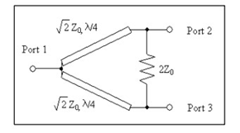
Figure 1. Basic design of WPD.
$$B= \frac{60π^{2}}{Z_{0}\sqrt{ε_{r}}}$$ | (3)
The length of the feed line can be calculated using (4):
Table 2
Optimized WPD Dimensions
Dimensions of WPD | Parameter (mm)
Lf₁ (Length of Feedline 1) | 2.3
Wf₁ (Width of Feedline 1) | 2
Lp₁ (Length of Patch 1) | 3
Wp₁(Width of Patch 1) | 1
Lp₂ (Length of Patch 2) | 2
Wp₂ (Width of Patch 2) | 1
Lp₃ (Length of Patch 3) | 2.5
Wp₃ (Width of Patch 3) | 2
Lp₄ (Length of Patch 4) | 4.5
Wp₄ (Width of Patch 4) | 2.3
Lf₂ (Length of Feedline 2) | 4.5
Wf₂ (Width of Feedline 2) | 2
Lf₃ (Length of Feedline 3) | 4.5
Wf₃ (Width of Feedline 3) | 2

$Wst= \frac{2h}{π}\left\{B-1-\ln\left(2B-1\right)+\frac{ε_{r}-1}{2×ε_{r}}\left[\ln\left(B-1)+0.39-\frac{0.61}{ε_{r}}\right)\right]\right\}$ | (4)
Furthermore, the equivalent dimensions of the power divider can be calculated using (5) and (6) [15]:

$Z_{0}=\frac{60}{\sqrt{ε}}ln\left(\frac{8h}{w}+\frac{w}{4h}\right)Ω$ $\frac{w}{h}≤1$ | (5)

${ Z}_{0}=\frac{120π}{\sqrt{ε\left[\frac{w}{h}+1.393+0.667\ln\left(\frac{w}{h}\right)+1.444\right]}}$ $Ω$ $\frac{w}{h}≥1$ | (6)
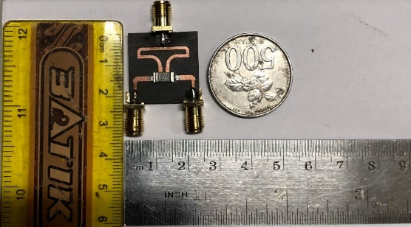
Figure 3. Realization of WPD.
Parametric studies were performed to optimize the WPD performance and obtain the required specifications. The initial theoretical design does not meet the desired parameter specifications; therefore, optimization is required. After optimization, the final WPD design was obtained, as shown in Figure 2. In isolation, the basic WPD structure consists of a quarter wavelength and a resistor between the two ports.
The design of the WPD simulation is shown in Figure 2. The design was obtained after calculating the WPD parameters. The dimensions of the calculation results used as design parameters are listed in Table 2. The actual values obtained in the calculations were not the same as the results in the simulation software, as can be seen from the response results on several graphs generated in the software. Therefore, more detailed optimization is required to obtain the results of some optimal responses. This change was made by increasing or decreasing the width and length of the microstrip dimensions, which can also be adjusted to the distance between the microstrips. This is usually performed in the design and simulation using microstrips. This change affects the simulation results, both the responses S₁₁, S₂₁, isolation, and response.

Results and analysis

Prototype
The WPD prototype is illustrated in Figure 3, where the dimensions of the power divider are small, 20.5 mm $×$20 mm, for a high frequency of 9.3 GHz. An SMA female jack male plug adapter solder edge PCB connector was installed as the input and output ports. The SMD 100 Ω resistor is placed between output ports 2 and 3 and then connected to the Keysight E5063A Vector Network Analyzer (VNA) to measure the frequency. The 100 Ohm resistor isolates the two output ports to prevent power leakage.
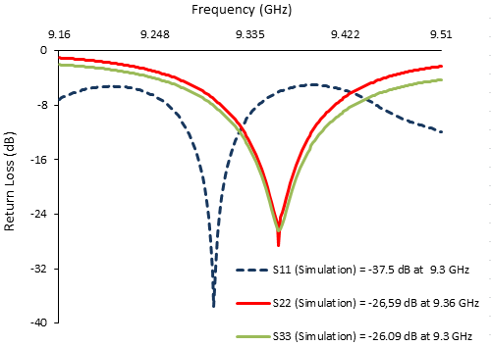
Figure 4. Simulation of WPD S-Parameter (S₁₁), (S₂₂), (S₃₃).
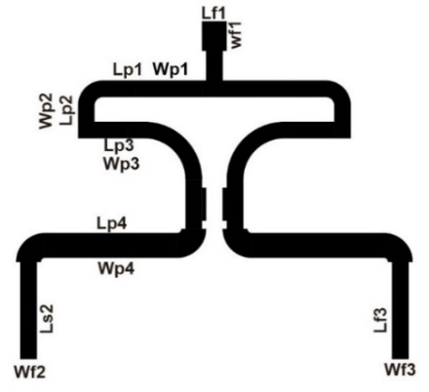
Figure 2. Design Of WPD.
The realization of the simulated design uses material from Roger Duroid 5880 with a microstrip line as a patch on the top layer with copper material, while the bottom is a full ground plane. Soldering is carried out on three ports consisting of one input port and two output ports to take measurements or obtain the desired response parameter values.

Simulated Results of S₁₁, S₂₂, S₃₃
The simulated S-parameters described in Figure 4,5, and 6, such as S₁₁, S₂₂, and S₃₃ have met the required specifications. The return loss was below -14 dB at a frequency of 9.30 GHz.
Figure 4 shows the resulting simulation graphs for (S₁₁), (S₂₂), and (S₃₃). At the operating frequency at the input port, the simulation results have an S-parameter response (S₁₁) of 9.3 GHz with a return loss of -37.5 dB. The response is also obtained at the first output of the S-parameter port (S₂₂) at a frequency response of 9.36 GHz with a return loss of -26.59 dB. And the other output responses shown, the S-parameter output (S₃₃), are still at a frequency of 9.36 GHz with a return loss of -26.09 dB. All response results from the simulation are already at the desired working frequency.

Measured/Realized Results of S₁₁, S₂₂, S₃₃
Furthermore, in the realization process, various responses were measured, as in the simulation that has been done to determine the difference or effect on the response between the simulation and the realization.
Figure 5 shows the results of measuring responses S₁₁, S₂₂, and S₃₃ to realize the WPD. Each result displays the S-parameter (S₁₁) with a return loss of -28.69 dB at a frequency of 9.29 GHz. The S-parameter (S₂₂) has a return loss of -28.5 dB at a frequency of 9.34 GHz, and the S-parameter (S₃₃) return loss value is -29.95 at a frequency of 9.34 GHz.

Comparison Simulated and Realized WPD Isolation (S₃₂)
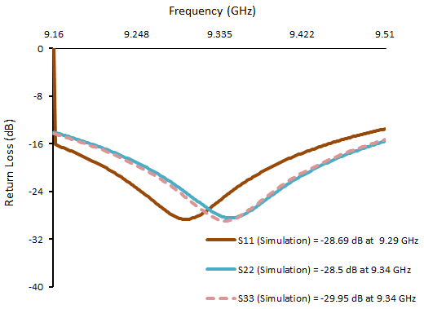
Figure 5. Measured WPD S-Parameter (S₁₁), (S₂₂), (S₃₃).
A good WPD is characterized by high isolation between its output ports. In this study, the isolation value to be achieved was ≤ -15 dB. Figure 6 shows a comparison between the simulated and realized isolation results. The isolation simulation results show -12.89 dB at a frequency of 9.3 GHz. When measurements were taken, the isolation was -21.89 dB at a frequency of 9.3 GHz. The difference in the simulation and the realization is caused by several factors, such as loss in the cable, less than optimal soldering, PCB that is not precise when fabricated, and the environment in which the measurement is carried out. Thus, the insulation results obtained when measured were much better than those obtained by the simulation. However, the simulation and measurement results showed that the isolation was still relatively high.
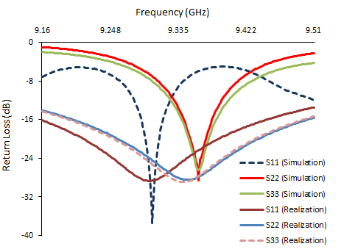
Figure 7. Simulated vs Realized Parameters (S₁₁), (S₂₂), (S₃₃).
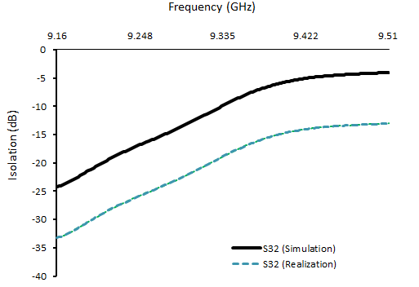
Figure 6. Simulated vs. Realized S₃₂.

Comparison of Simulated and Realized Parameter S₁₁, S₂₂, S₃₃
Figure 7 shows the comparison graphs of S₁₁, S₂₂, and S₃₃ for the simulation and realization results. There is a 10 MHz frequency shift for S₁₁ when measured. The simulated frequency of 9.3 GHz shifts to 9.29 GHz when measured. The lowest return loss (-37.5 dB) was obtained at 9.30 GHz for the simulation results and -29.95 dB at 9.34 GHz for the measurement results. A shifted frequency of 20 MHz was also observed for the measured S₂₂ and S₃₃. The simulation frequency of 9.36 GHz is shifted to the measured frequency of 9.34 GHz. Overall, the simulation and realization results have the required specifications.

Comparison of Simulated and Realized Parameter S₂₁, S₃₁
Figure 8 shows the comparison results for the simulated insertion loss measured using the WPD. In the simulation results for S₂₁, the insertion loss is -3.61 at a frequency of 9.35 GHz. When measurements are taken, the insertion loss value shifts to -6.61 dB at a frequency of 9.35 GHz. The S₃₁ simulation results show an insertion loss value of -2.55 dB at a frequency of 9.33 GHz. At the Time of measurement, there was a shift in the insertion loss value to -7.55 at a frequency of 9.33 GHz. We realized that designing a microstrip WPD with a mini size at 9.3 GHz will yield a high insertion loss value compared to a waveguide. However, for MPSR applications, size is critical. The insertion loss values ​​obtained from the simulation and testing were still acceptable in MPSR testing. The difference between the simulation and fabrication results can be attributed to cable loss and environmental factors.
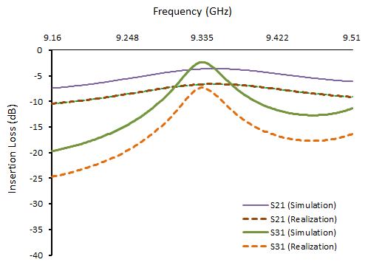
Figure 8. Simulated vs. Realized Parameters (S₂₁) and (S₃₁).

Table 3
Comparison of WPD Design with Previous Research
Ref. | Freq. (GHz) | Dimensions (mm) | Substrate | Simulation | Mesurements
[15] | 9.5 | GCPW :10.6$×$17.88  Microstrip: 24.65$×$48 | RT Duroid 6002  h = 0.762mm  εr = 2.94  δ = 0.0012 | GCPW  (S₁₁) -37.03 dB  (S₂₁) -3.185 dB  (S₃₂) -13.08 dB  fractional bandwidth 31.25 %  deviation 0.185 dB  Microstrip Transmission  (S₁₁) -10.144 dB  (S₂₁) -3.985 dB  (S₃₂) -23.7 dB  deviation 0.985 dB  fractional bandwidth 5.478 % | -
[4] | 9.3 | - | RT Duroid 5880  εr = 2.2  h =1.557 mm δ = 0.0009 | (S₁₁) -30.073 dB  (S₂₂) -30.448 dB  (S₃₃) -31.217 dB  (S₂₁) and (S₃₁) -3.059 dB  (S₃₂) -29.541 dB | -
[2] | 9.3 | - | RT Duroid 5880  εr =2.2  h= 0.78 mm | (S₁₁) <-20 dB  (S₂₁) and (S₃₁) < -3 dB | -
[6] | 9.5 | 43.0749$×$60.7945 | Roger 5880  εr = 2.2  δ = 0.0009  h =1.574 | (S₁₁) -23.1 dB  (S₂₁) -3.54 dB  (S₃₁) -3.68 dB  (S₃₂) -16.23 dB | -.
[7] | 2.4 | - | Roger 4350B  εr =3.48  δ =0.0037  h = 0.17 | (S₁₁) -18 dB  (S₃₂) -29 dB | (S₁₁) -22 dB  ( S₃₂) -33 dB
This paper | 9.3 | 20.5$×$20 | RT Duroid 5880  εr = 2.20  h = 1.575  δ = 0.0009 | (S₁₁) -37.5 dB  (S₂₂) -26.59 dB  (S₃₃) -26.09 dB  (S₂₁) -3.61 dB  (S₃₁) -2.55 dB  (S₃₂) -12.89 dB | (S₁₁) -28.69 dB  (S₂₂) -28.5 dB  (S₃₃) -29.95 dB  (S₂₁) -6.61 dB  (S₃₁) -7.55 dB  (S₃₂) -21.89 dB

Comparison of designed WPD with previous studies
Table 3 shows the comparison of the WFD between the results obtained in this design and the previous studies. It can be seen that the WPD can be designed with x-band or s-band frequencies according to the desired needs. A WPD designed using Roger 5880 material is included in this design because it can be used at x-band frequencies with good stability. Furthermore, the design dimensions of this study show that the overall size dimensions produced by the WPD are smaller than those of some previous related studies, with a size of 20.5$×$20 mm². In this design, both the simulation and the realization produce a fairly good isolation, even if the isolation at the measurement time is higher than during the simulation. The result is following the main principles of the WPD. Several previous studies have not produced WPD that were fabricated and realized. Thus, overall, the WPD produced in this study had much smaller dimensions with good isolation during simulation and realization.

Conclusion
This study succeeded in designing, simulating, and developing a mini-compact Wilkinson Power Divider operating at a frequency of 9.3 GHz with dimensions of 20.5 mm$×$20 mm for MPSR applications. The proposed WPD uses Roger 5880 as the substrate material with a thickness of 1.575 mm. The simulation results obtained are the lowest return loss on S₁₁ of -37.5 dB at a frequency of 9.3 GHz, S₂₂ -26.59 dB at a frequency of 9.36 GHz, S₃₃ -26.09 dB at a frequency of 9.36 GHz, with insertion loss S₂₁ -3,61 dB at a frequency of 9.35 GHz and S₃₁ -2.55 dB at a frequency of 9.33 GHz, then Isolation S₃₂ -12.89 dB at a frequency of 9.3 GHz. There was a 10 MHz frequency shift for S11. The simulated frequency of 9.3 GHz shifts to 9.29 GHz when measured. The lowest return loss obtained is -29.95 dB at a frequency of 9.34 GHz for the measurement results. A shifted frequency of 20 MHz was also observed for the measured S₂₂ and S₃₃. A decrease in the realization of insertion loss also occurred in S₂₁ and S₃₁ at the 9.33 GHz and 9.35 GHz frequencies due tocable and environmental losses during the measurement process. However, all the actual results obtained are still in the good category.

Declarations

Conflict of Interest
In compiling this paper, the authors solemnly declare that there are no competing interests.

CRediT Authorship Contribution
Yusnita Rahayu: Conceptualization, Methodology, Resources, Writing-Reviewing and Editing, Supervision, Funding acquisition; Lara Putri Utami: Software, Validation, Investigation, Data curation, Writing-original draft, Project administration; Teguh Praludi: Validation, Investigation, Writing-Reviewing and Editing, Visualization, Supervision; Topik Teguh Estu: Investigation, Resources; Yussi P. Saputera: Resources, Project administration, Funding acquisition; Anhar: Formal analysis, Project administration.

Funding
Research reported in this publication was supported by Kedaireka- Indonesia Ministry Education, Culture, Research, and Technology under Matching Fund 2022.

Acknowledgment
The authors would like to thank Kedaireka for the financial support under the Matching Fund Project. This project is a collaboration between our university and industry. The authors also thank the Research and Community Service Agency of Universitas Riau for their research management service.

References
[1] K. Paramayudha, Y. S. Amrullah, and Y. Wahyu, “X-band antenna design for Indonesian ground surveillance man pack radar,” in 2016 2nd Int. Conf. Ind. Mech. Electr. Chem. Eng., Oct. 2017, pp. 1–3, doi: 10.1109/ICIMECE.2016.7910413.
[2] F. Oktafiani and Y. Wahyu, “Fabrication of integrated power divider and filter for x band radar applications,” in 2018 Int. Conf. Electr. Eng. Comput. Sci., Oct. 2018, vol. 17, pp. 33–38, doi: 10.1109/ICECOS.2018.8605261.
[3] D. O. González, “Design of an unequal wilkinson power divider for vhf radar,” Revista Telemática, vol. 20, no. 1, pp. 66–75, 2021. [Online]. Available: https://revistatelematica.cujae.edu.cu/index.php/tele/article/view/440.
[4] W. Desvasari et al., “2 way wilkinson power divider for x band navigation radar,” J. Phys. Conf. Ser., vol. 1501, no. 1, 2020, doi: 10.1088/1742-6596/1501/1/012001.
[5] G. Bharathy, M. Guruprakash, and M. Mounika, “Design and simulation of equal and unequal wilkinson power divider,” in ICIETET’20 Int. Conf. Innov. Emerg. Trends Eng. Technol. June 26-27, 2020, 2020.
[6] N. Mohamed, S. Y. Mohamad, N. Farihah, A. Malek, F. Nadia, and M. Isa, “A compact and lightweight microstrip antenna array with Wilkinson power divider for x-band application at 9.5 GHz,” in 2019 IEEE Asia-Pacific Conf. Appl. Electromagn. (pp. 1-5). IEEE., Nov. 2019, pp. 25–27, doi: 10.1109/APACE47377.2019.9021074.
[7] K. Masrakin, M. I. Zulkepli, S. Z. Ibrahim, H. A. Rahim, A. A. Dewani, and M. N. A. Karim, “Compact 2-way power divider for IoT application,” J. Phys. Conf. Ser., vol. 1755, no. 1, 2021, doi: 10.1088/1742-6596/1755/1/012040.
[8] Y. J. Ren, “Low-profile wearable uhf antenna for portable radios and radar applications,” in 2011 30th URSI Gen. Assem. Sci. Symp. URSIGASS 2011, 2011, pp. 0–3, doi: 10.1109/URSIGASS.2011.6050407.
[9] A. Altaf, C. Xi, U. Dilshad, and J. Miao, “Design of compact c-band one into eight-way equal Wilkinson power divider,” in 2019 Int. Conf. Microw. Millim. Wave Technol. (pp. 1-3). IEEE., May 2019, vol. 1, no. 1, pp. 1-3, doi: 10.1109/ICMMT45702.2019.8992407.
[10] S. Lotfi, S. Roshani, and S. Roshani, “Design of a miniaturized planar microstrip Wilkinson power divider with harmonic cancellation,” Turkish J. Electr. Eng. Comput. Sci., vol. 28, no. 6, pp. 3126–3136, 2020, doi: 10.3906/ELK-1911-104. doi: 10.3906/elk-1911-104.
[11] G. Arican, “A compact 2-way multisection power divider for broadband operations,” J. Sci. Reports-C, vol.002, pp. 1–10, 2021. [Online], Availabe: https://dergipark.org.tr/en/download/article-file/2405857.
[12] H. S, T. Hariyadi, and A. B. Pantjawati, “Design and realization of multi-section sum and diff 8 ways wilkinson power divider at s-band frequency for 3 dimensional radar application,” IOP Conf. Ser. Mater. Sci. Eng. vol. 850 012058, pp. 1-10, 2020, doi: 10.1088/1757-899X/850/1/012058.
[13] D. R. Khoirini, T. Hariyadi, and A. B. Pantjawati, “Design and realization of 4-way Chebyshev Wilkinson power divider at 3 GHz frequency for 3-dimensional radar application,” IOP Conf. Ser.: Mater. Sci. Eng, vol. 850, pp. 1-7, 2020, doi: 10.1088/1757-899X/850/1/012059.
[14] M. M. Sharma, I. B. Sharma, P. Kaith, and J. Garg, “Design and performance evaluation of circularly polarized dual-feed microstrip patch antenna using Wilkinson power divider,” in 2021 IEEE Indian Conference on Antennas and Propagation (InCAP), 2021, pp. 12-14. doi: 10.1109/InCAP52216.2021.9726355.
[15] C. B. Ali, M. H. Chishti, U. Anjum, U. Afzal, and A. Hussain, “Miniaturized grounded co-planar waveguide based x-band equal split Wilkinson power divider for aesa application,” in 2020 IEEE 23rd Int. Multitopic Conf., 2020, pp. 1–6, doi: 10.1109/INMIC50486.2020.9318157.

